Day Two: Using Programming Within ArcGIS

Brief

Welcome to Day Two - and when, as they say, the fun really begins! Today, we are going to be introducing you to a lot of high-level programming concepts as well as detailed code that you’ll need to check - and most likely debug! Attention is key - but ask for help if you need it!

What you’ll do today:
- Learn how to build a more complex workflow using ModelBuilder.
- Add iterators into our models to automate the ingestion and processing of multiple datasets.
- Build an extended script to process the datasets within an ‘Integrated Development Environment’
- Transfer the iteration method into ArcPy and Python code using listing logic and for loops.
- Bring the methodology together under one script so you can repeat it again and again, with other sets of data!

Background: automaton, automation, automation

There is an unreferenced quote that “80% of GIS work is actually just data processing (and management)” - and for all of us here, we’ve found out this to be so very true. Finding the right data is often the first big hurdle you have to overcome with any GIS research project. The next hurdle - getting the data in the right format and then into the right output for analysis - requires more critical thinking about what exactly it is you’re trying to achieve and how you’re going to get there, as you found yesterday. The actual analysis of the data is usually the simplest - and quickest - step. Today, we’ll primarily be focusing on finishing the processing of our data so we can then analyse it. The idea is to be able to set up our processing within ArcMap so that it is automated. i.e. we only need to provide inputs to a model or script and an output can then be generated by running said model or script. Often we need to repeat an analysis for multiple datasets, timepoints - or simply a few months down the line - and having our processing already automated makes this a lot easier! Furthermore, having it written as a script means that it is documented, making it easier and quicker to review or share your methodology in the future.

But setting this automation up is not easy. Even for those familiar with the tools or programming functions you can use to automate our processing steps, it can be a slow and arduous process. It requires trialling and testing - and research into these tools - to get to this stage. Often this takes more time than it would to just manually run the steps yourself - but the more you try to automate tasks, the faster you get at automating the steps. And the hard work will start to pay off. Plus for those interested in a career in data science or research, you’ll find out often, the more data the better, so you won’t want to run a lot of these processing steps manually!

Part Four: Building Complex Workflows in ModelBuilder

Being able to build up longer workflows, rather than typing in a single command at time, is a fundamental part of programming. Take, for example, our processing for Step 2. We had to run two processes in succession on two csvs. It would be great to be able to run both of these processes automatically one after another - as well as automate the processing of the data itself. Even if we only had just a few more csvs to process, it would be beneficial not to have to enter (or edit) every path to the csvs we want to process and by automating this ‘ingestion of data’, it would mean that we wouldn’t have to wait around for each dataset to be processed and then start the processing again on the next. Being able to automate not only the processing steps but also the ingestion of the data therefore would not only save us time, but also free up time for us to do other things whilst the workflow is running in the background. We end up being pretty darn efficient - and if that’s not a selling point to future employers, we’ll buy you a slice of cake*.

To be able to automate this ingestion and processing, we need to understand and use some of the fundamental programming concepts including variables, iterators (also known as loops) and substitution. For the first part of this today, we’re going to use the final window within ArcMap, ModelBuilder, to become familiar with these concepts in the ArcMap environment.

The second half of the day, we’ll translate everything we’ve learnt to writing up a full script from start to finish using ArcPy and within a scripting environment (IDLE) and identify how and when to use these different concepts.

Step Three: Calculating Crime Rate in Southampton LSOAs (ModelBuilder - Basic)

You’re either going to love it or hate it, but ModelBuilder is an incredibly useful feature within ArcMap to know about – many very competent and efficient GIS analysts may not know how to code but instead are able to use ModelBuilder to create extensive and iterative workflows. If you find that by the end of the course, you’re really not enjoying the coding, it is definitely an alternative to use (and figure out all of its utilities!). It’s also a great place to get started thinking with a more logical programming approach.

1. From your Bootcamp_Processing.mxd, open up the ModelBuilder window. Expand the box to cover the map canvas – it’s useful to have access to Catalog and Search on the right-hand side, so don’t cover up these windows.

2. Look through the ModelBuilder menu options at the top. There’s not a huge amount of choice or options, but our most important tab, Insert, has pretty much everything we need:

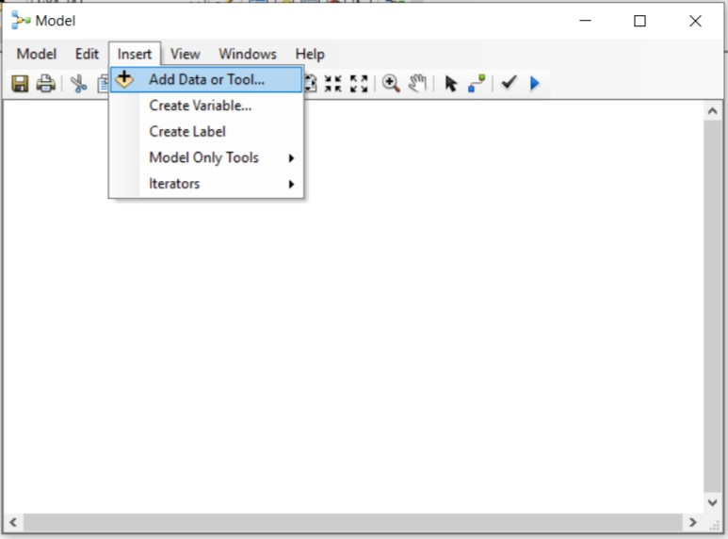

3. We just need to understand how to use them.

ModelBuilder: The basics of building a model

ModelBuilder builds models using three main components: variables, tools and connectors.

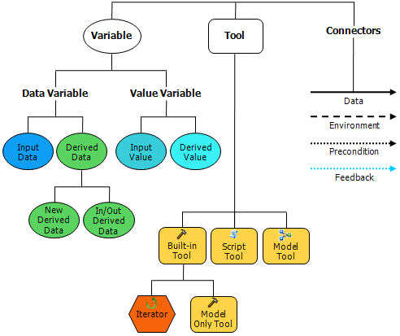
Whilst we’re pretty familiar with the idea of a tool, both the words ‘variable’ and ‘connectors’ are quite new to us within ArcMap.
Variables are the most fundamental part of programming - variables are elements (in ArcMap model) or objects (in a Python script) that are used to store some type of information that can then be accessed by a model or script and used for some sort of processing (i.e. within a tool or function).
In the case of ArcMap, a variable can store one of two things:
First, a variable can store a value, which can be defined beforehand (Input Values), or created from the result of a calculation carried out during the model (Derived Value). These values can be strings, numbers, Booleans, spatial references, linear units or extents. Value variables can contain anything but references to data stored on disk.
Secondly, a variable can also store a dataset; what is meant by that is that the variable is set to the reference of the dataset, e.g. its full path or its layer name, but will also store other properties about the data, such as field information and spatial reference. These datasets can be an Input Dataset, or data derived during the model processing.
There are quite a few differences in how variables are interpreted between ArcMap and pure Python, however the main understanding across both is that a variable will store some type of information (a value, data path) in its memory that can then be accessed and used by the model or script.
Connectors in ArcMap connect these variables, data and values, to the tools we want to use for processing. There are four types of connectors:
- Data: The primary connector you’ll use - it connects data and values to tools, setting them as an Input or Output - just remember with some tools, such as Spatial Join, you’ll have two Inputs to connect.
- Environment: Connect a variable containing an environment setting (data or value) to a tool. When the tool is executed, it will use this environment setting.
- Precondition: Connects a variable to a tool. The tool will only work if the conditions of the variable are settled.
- Feedback: Connects the output of a tool back into the same tool as a new input.
Whilst we’ll be primarily be using (1) Data connectors, it’s good to be aware of the other connectors as you may come across uses for them in future work.
4. You’ve had a brief introduction to ModelBuilder and perhaps not quite understood everything. But don’t worry - the best way to learn new things is to get stuck and then find ways to solve your problems (as we’ll do a little later on).
5. To help demonstrate the use of different variables, let’s get going and start to build our model for processing one of our crime csvs into a crime rate.
6. You should still have the ModelBuilder window open. Just like with the Console, we can use the click and drag method to populate ModelBuilder. From our crime csv folder, drag the csv for April 2016 into the ModelBuilder window.
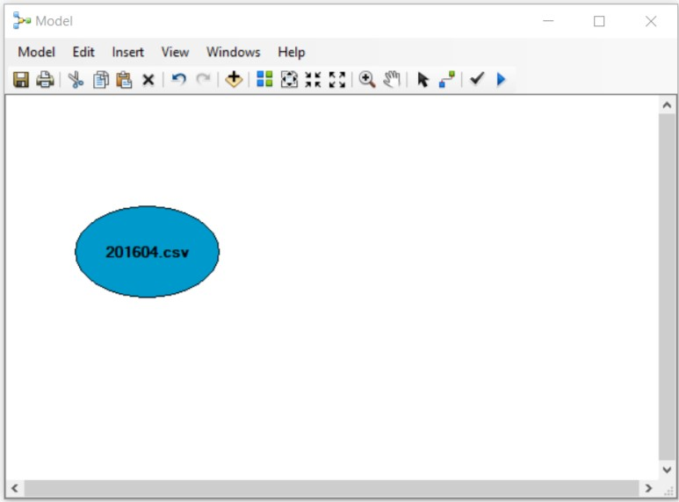

7. You should find that an Input shape appears with our April 2016 csv (201604.csv) written in the centre. We have just created our first data variable. If you double click on the shape, you’ll be able to see that the data variable, currently named 201604.csv actually stores the path to our csv. Close the window.

8. To make our model more readable, we can rename our variable to something more descriptive. If you right-click on the shape, you can rename the variable to: crime_month_csv. Double-click on the shape again and see what’s changed in the box. You can see that the name of our variable has changed but not the path. We now have a variable, crime_month_csv, which is equal to the path of our current crime dataset of interest.

9. Next we want to add our first step of processing – check back to your methodology flowchart if you’re unsure what we will do next.

10. You can access all your Geoprocessing tools from the menu within ModelBuilder – or more easily from the Search bar on the right-hand side as we did before. The first step of our method is to is to map our crime data; we therefore need to display our Coordinates as an X and Y event. Find and then drag and drop the Make XY Event Layer tool into the ModelBuilder window. As you can see, the tool and its output are not coloured in - this is because they are not ready to run and require further input.

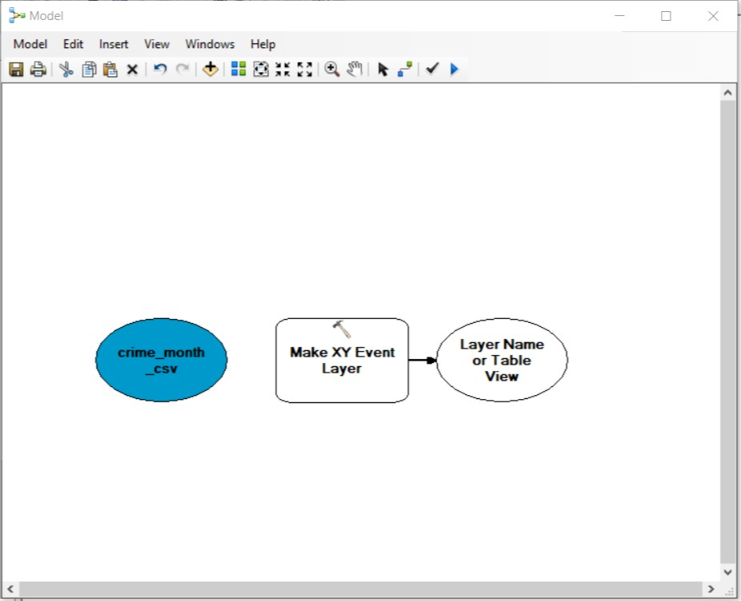

11. We now need to connect our Input to our Process – to do so, you can use the connector button, . Click on our crime_month_csv variable, and drag into the Make XY Event Layer process.

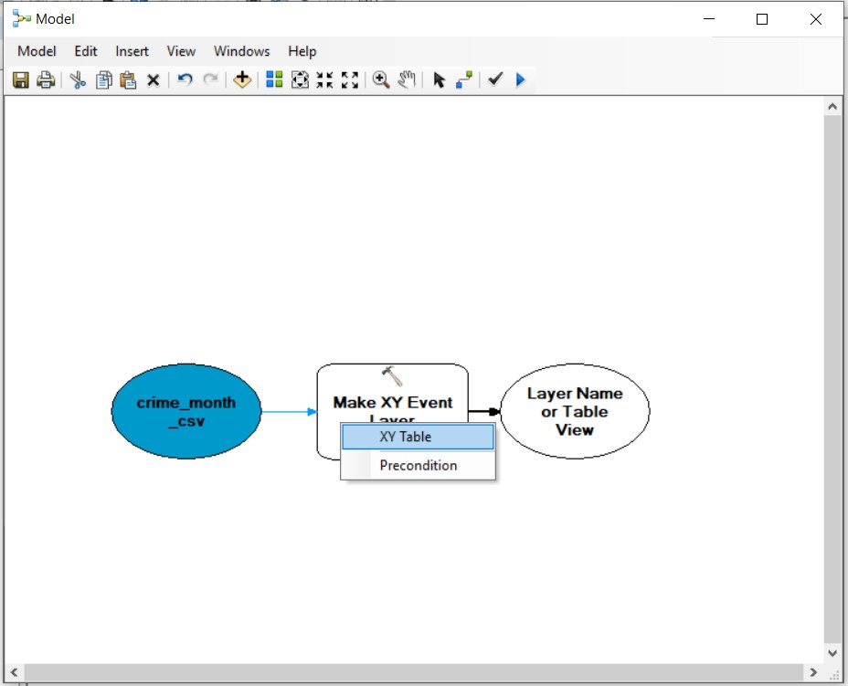

12. ModelBuilder gives you the option of using our Input in different ways – but of course we want it to be used as the XY Table, rather than the Precondition. Once entered a new output appears on the other side of our process; this will be the temporary layer created from our Make XY Event Layer tool.

13. Double-click on the Make XY Event Layer process to open the tool to check and set our parameters. As you will still have the Connector open, you’ll need to click on the black Select arrow to be able to open the tool.

14. From the open tool, you can set the new layer name. Set it to crime_points_201604. Check that the Longitude and Latitude fields are entered into the respective X and Y Field parameters. Check that the Spatial Reference is set to GCS_WGS_1984 - if not, make sure to set this parameter. You can then click OK - this won’t run the tool in ModelBuilder but just apply all the parameter settings you’ve just entered.

15. Our two new shapes now fill with colour as we’ve filled in their requirements. We have also created our second data variable - the output layer from the Make XY Event Layer process. The data variable stores the output from the process, our temporary layer, crime_points_201604. But we want to give the actual variable a new name - something that is more generic and does not include the precise date. Right-click and rename, removing the ‘_201604’ to simply call our variable crime_points. Again, you can click on our crime_points variable to check that it still stores our temporary layer, crime_points_201604.

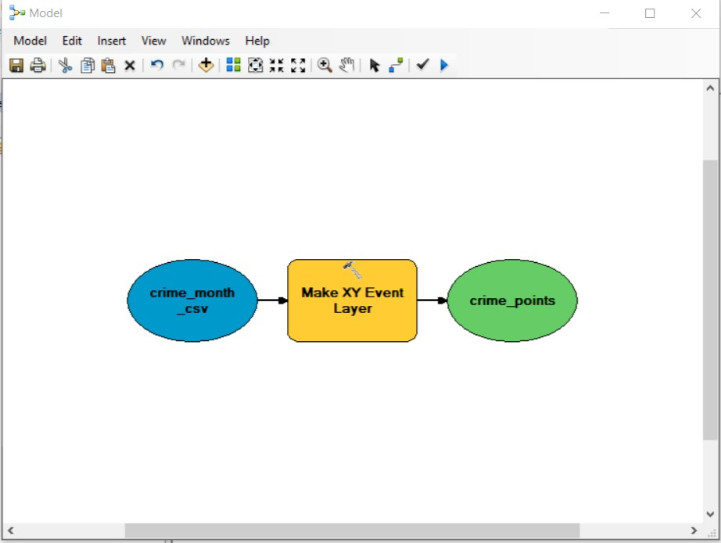

16. The next step in our processing will be to extract only crime that is related to PSPOs – as discussed yesterday, we’ll be focusing on ‘Public order’ and ‘Anti-social behaviour’. To extract only this crime from our points, we’ll be using the same Select tool we used yesterday to extract our Southampton LSOAs. Drag and drop the tool into the ModelBuilder window.

17. Connect the crime_months_points variable to the Select tool as the Input Features. We then need to set our Selection Query.

18. Double-click on our Select process to open the tool and enter a query to select only the ‘Public order’ and ‘Anti-social behaviour’ from the Crime Type field.

Note, it may be the case that you are unable to load all unique variables for Crime Type into the SQL builder - this is because the number of rows is just too big for ArcMap to cope with! As a result, you will have to write out your query yourself! You may also not get your expression verified - it should still run. We have had a few problems in testing so if it doesn’t when you execute your model, let us know.

Complex SQL Queries

Our query to select two types of options from a field requires a slightly more complex syntax than our previous query, and requires the use of a BOOLEAN operator to connect two conditional expressions. When you use a boolean operator, the second expression needs to follow the same format as the first i.e. the field, the qualifier and then the value of that option. For example, taking our Southampton LSOA pop dataset from earlier, if we wanted to extract those LSOAs that had populations over 1000 people in both 2016 and 2017, our query would look a little like this:

“lsoa11nm” LIKE ‘Southampton %’ OR “lsoa11nm” LIKE ‘Portsmouth %’

Note how the Boolean (OR) connects the two separate expressions into one – it still requires the field and the qualifier – and does not look like this:

“lsoa11nm” LIKE ‘Southampton %’ OR ‘Portsmouth %’

This query is incomplete and won’t work! Head back to the Syntax help link if you get stuck.

19. Once you’ve written out your query, rename your output to PSPO_crime_201604 but keep this output within our default geodatabase, Bootcamp.gdb, as a feature class. Next, click OK. on the tool.

20. We’ve now created our third data variable, which stores the output of the Select process i.e. our new feature class. But again, we want our variable to be more generic (like the ones preceding it) so let’s rename the variable by removing the _201604 suffix.

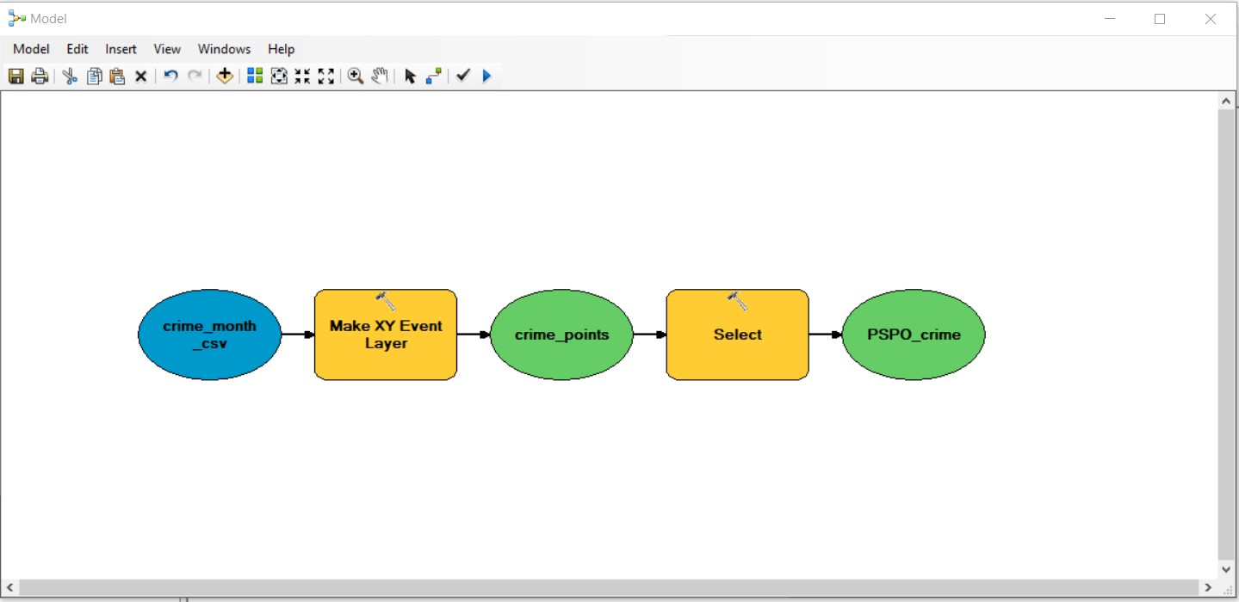

21. The next step in our workflow is to join our crime data with our Southampton LSOA population dataset. Drag and drop the final dataset we created yesterday into the ModelBuilder window i.e. the reprojected dataset. Rename our new variable, Admin_Pop_dataset.

22. Drag the Spatial Join tool into the window. Connect the Admin_Pop_dataset and PSPO_crime variables to the Spatial Join tool. Think carefully about which will be our Target Features and which will be our Join Features.

23. We want to edit some of the parameters in our spatial join so will need to open the tool. The first is to change our Output Feature Class - we want to set to a shapefile within our processed folder. Call it Southampton_LSOAs_Crime_201604.shp.

24. Next, we want to reduce the number of fields that are joined to our Target Features. We don’t need all the additional data that comes with the csv, we’re only really interested in the Join Count, which will be added automatically by the tool. Remove all of the fields joined from the PSPO_crime feature class. Make sure you keep our original fields from our Southampton_LSOAs_Pop_WGS84.shp - although you can remove the additional lsoa11nmw field and area/length fields if you have them. Finally, set the Match Option to CONTAINS. Your field map should look as below:

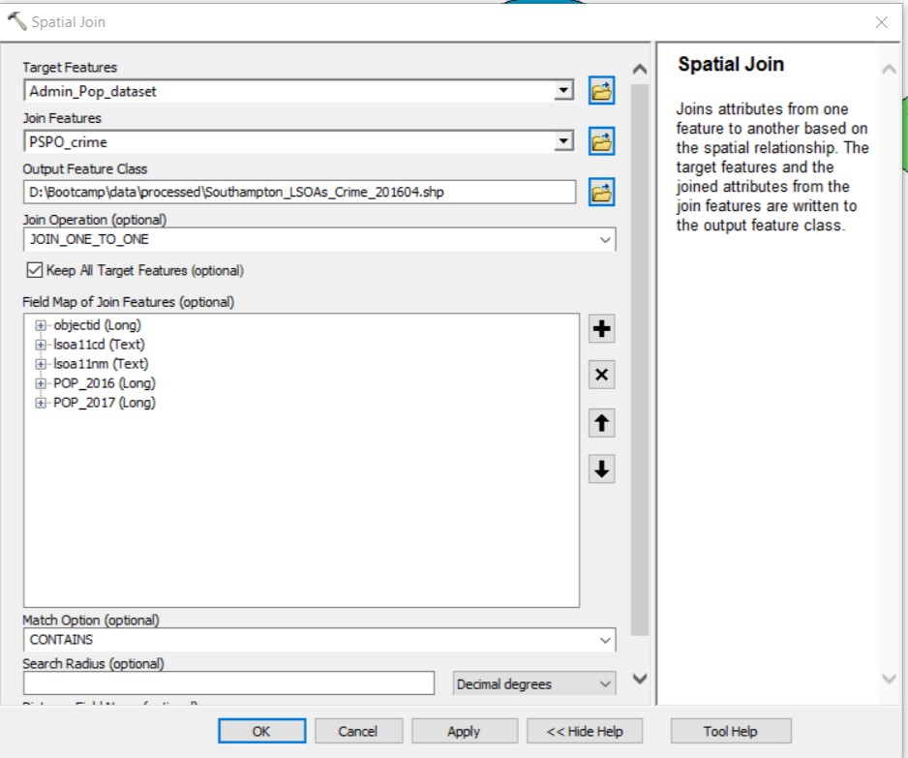

25. We’ve edited all the parameters that we’re concerned with right now. Click OK on the tool.

26. Rename the data variable by removing the suffix again (Southampton_LSOAs_Crime).

27. From the count output of our Spatial Join process, we will now have the total number of PSPO-related crime for each LSOA in Southampton (and in this case) for April 2016. As discussed yesterday, having a count is not sufficient to be able to compare both spatial and temporal changes - we need to account for variations in the population that can lead to changes in crime amount. To do so, as we’ve already joined our population data for 2016 and 2017 to our LSOA shapefile, we just need to divide our crime count by the correct population (i.e. for now, we’ll be using the 2016 population). To create this Crime Rate, we first need to add a new field to our dataset and then calculate the rate.

28. Drag the Add Field (Data Management) tool into the model. Connect the output of the spatial join to the Add Field tool. Double-click on the tool to set the parameters. First we add a Field Name. Always try to start a field name with a letter and not a number - it’s a weird bug in ArcMap, but using numbers are likely to throw off future code. Let’s call our field CR201604 (Crime Rate, April 2016). Set the Field Type to a DOUBLE as we want to be able to use decimals, not integers. We won’t worry about Field Size or Precision for now, but this is something we could set later on to tidy up our data. Click OK.

29. Rename the data variable, again by removing the suffix but this time add [2]. Frustratingly, ModelBuilder will not let you update your old variable with a new value (i.e. in this case, the same feature class but with a new field). The resetting of variables is a common technique used in programming, and one we will come to later. But it is these sorts of limitations that we can point out now to highlight why you shouldn’t limit yourself to only learning a tool such as ModelBuilder.

21. Now we have a new field, we want to add our values to it. Drag the Calculate Field tool into the model and connect the output from our Add Field tool. Open the tool. Select the newly added field as our Field Name. Then use the Query Builder to build our calculation. Notice that there is an option to build our query using either VB Script (Visual Basic) or Python. Stick with the VB option for now and use the Fields to enter our fields correctly and click OK when you’re happy with our calculation. Click OK on the tool.

31. Rename our final variable, Southampton_LSOAs_Crime_Rate.

32. And that’s it. That’s our tool built. If yours is a bit of a mess, you can use the 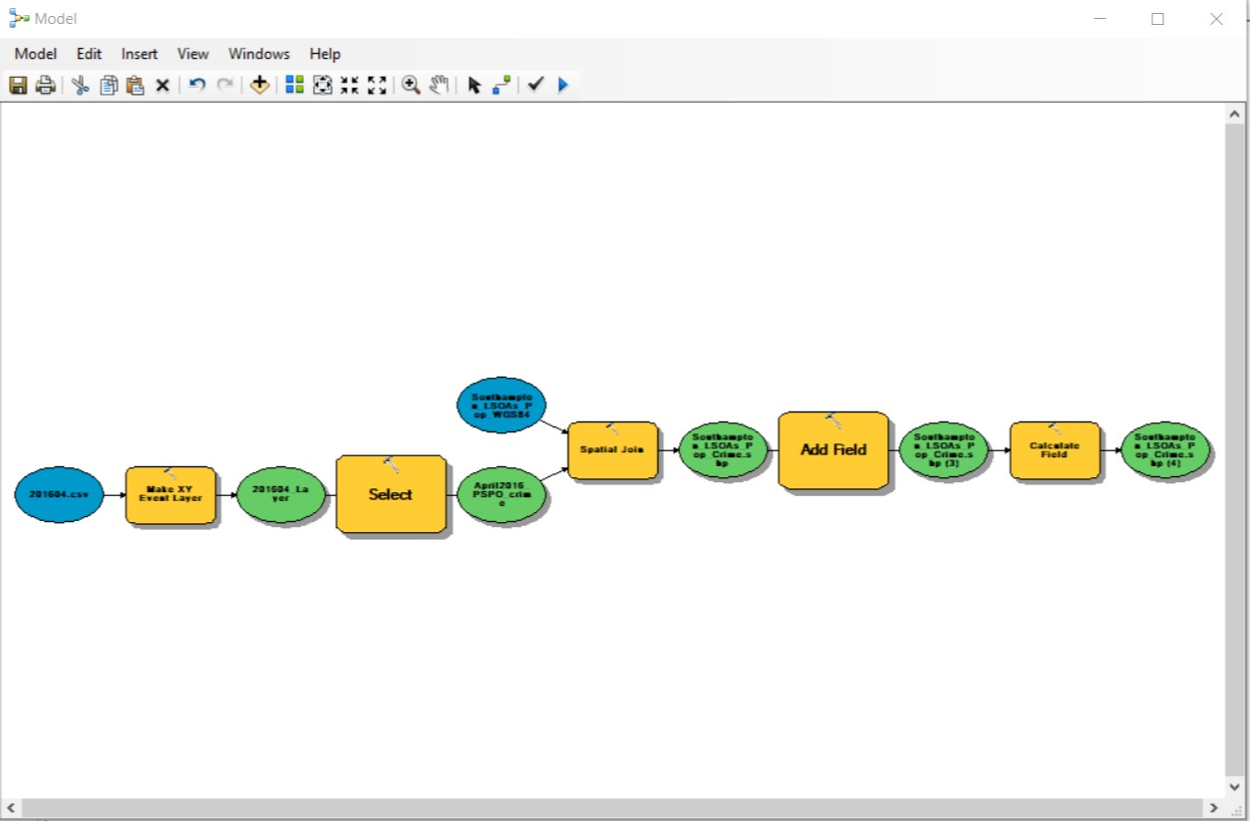 button to get ArcMap to reorganise the shapes. Next you can click the to see the whole model in a single extent.

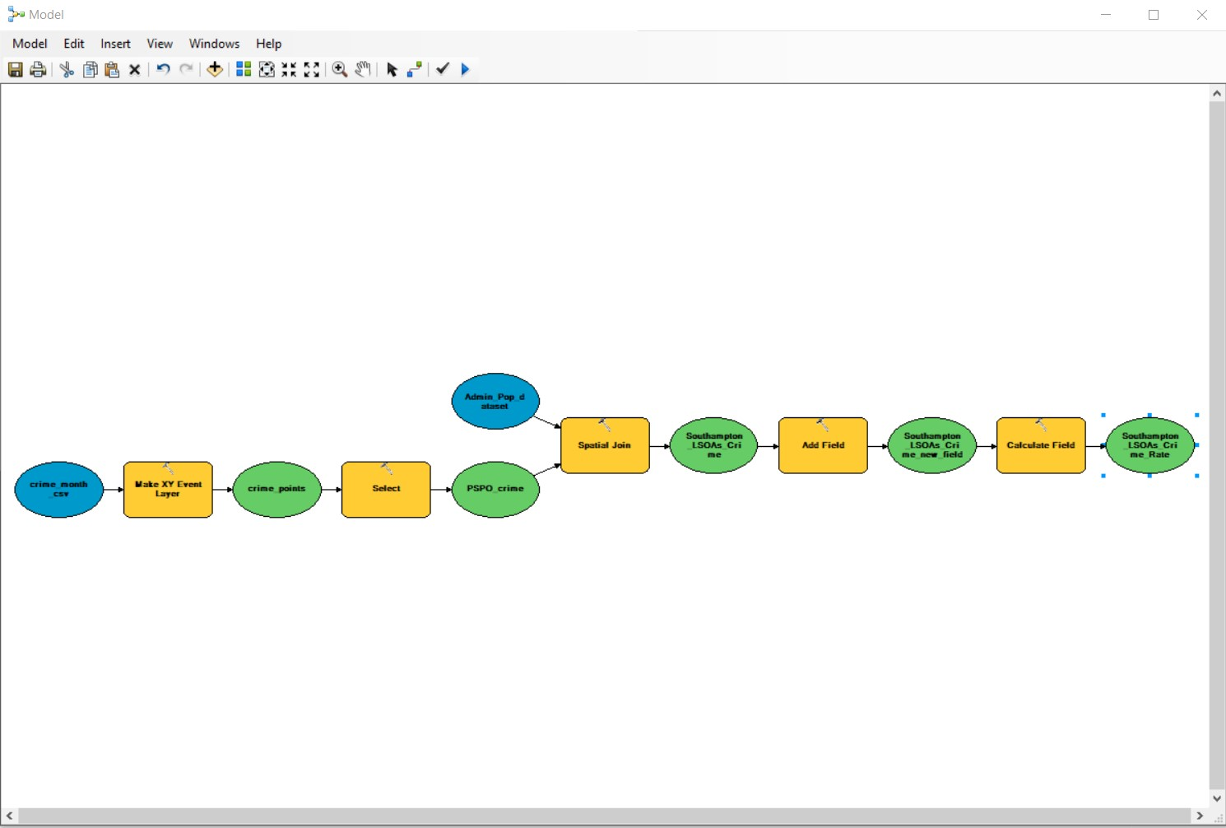
33. The next thing we want to do is validate our model using the button. The validation let’s ArcMap quickly run through our model to check that all the necessary parameters are set. As long as everything seems good, you won’t have any feedback from ModelBuilder.

34. Great - let’s first save our model (just in case ArcMap crashes, we don’t exactly want to lose all of our work!). To do so, we need to save the model as a tool within a toolbox. Click on File → Save As and navigate to the src folder. We first want to create a new toolbox within which to save our tool. Name your toolbox, Processing. Double-click on the Toolbox to save the tool within it. Call your model Crime_LSOA.

35. We’re now ready to run our model. Click the button. You should see black shadows appearing under your model, as well as the Run box that has appeared running through the processes. The Green status bar should complete and the model should state Completed. And, of course, your new datasets should appear within your folders and geodatabase.

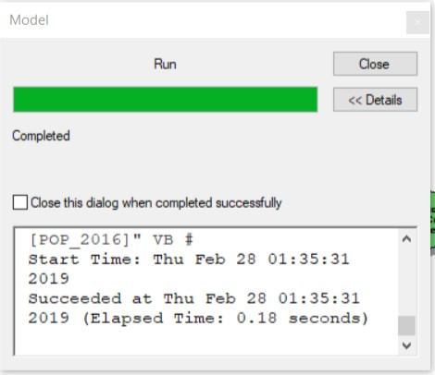

36. Any red text or an incomplete Green Bar means that the model has run into an error. The model should let you know where you have an error - and hopefully more detail about what you need to change. If you think you have fixed the error yourself, you may need to use the Validate button to reset your model. You know that you have reset your model as the black shadows underneath the shapes will disappear. Without resetting your model, your model will run from the last point it got to. If you had a simple fix that did not involve deleting any data, this might be ok - but if you have had to change something significant or delete a dataset, you’ll probably need to run your model from the start. It’s also good practice to do so, to make sure (a) your model does work completely and (b) you don’t introduce any errors into your datasets. If you run into any difficulties running the model, please let us know. You should check your datasets to make sure each stage of the model has worked - for example, checking that the Select function worked to only export the types of crimes we are interested in - you’ll find that output in your geodatabase.

37. And that’s it - we’ve created a model to automate our processing. In the end it was pretty simple and quick to build up this extensive workflow. What we can do next is turn this model into a tool so we can run the same processing on multiple datasets.

Turning our model into a working tool

38. For now, close down your ModelBuilder window. Instead, we can access our model as a tool from the Catalog window. If you navigate to your src folder, you’ll see the new Processing toolbox and then your Crime_LSOA tool. Click on the tool to open it.

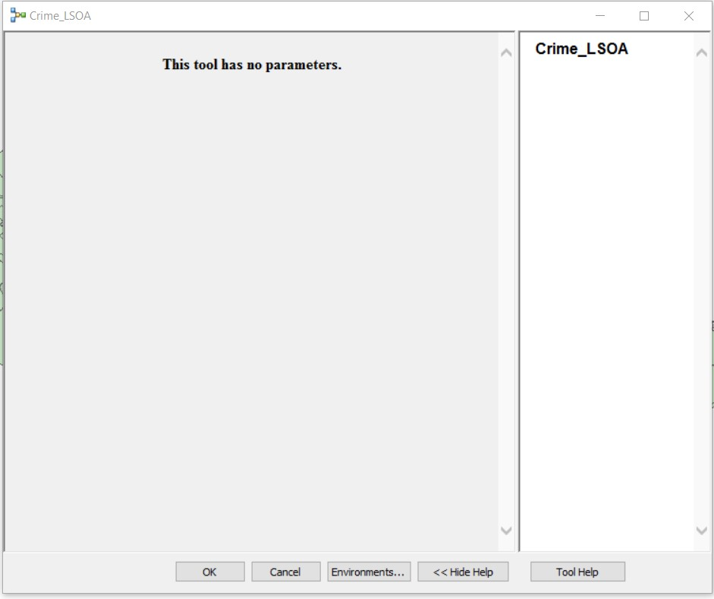

39. Ok, it doesn’t quite look like the tools we’ve used in ArcMap - and that’s because we haven’t actually set our tool with any parameters, e.g. the names of input datasets, output datasets and other arguments, such as the name of a new field, that we’d probably need to use to run the tool on a new dataset.

40. We can set these parameters within ModelBuilder. To do so, close the Tool window but now open it within ModelBuilder - the quickest way to do this is to right-click on the tool and click Edit.

41. We now want to parameterise parts of our model - to understand what we need to set as parameters, think about what you’d need to change to run this model on the May 2016 data.

42. The first parameter we’d need to set is the Input Dataset. Right click on the crime_month_csv variable and click on the option to set as a Model Parameter.

43. The next parameters we’d need to set is the path and filename of any outputs from the processing. We know that the the output from Make XY Event Layer tool is temporary so we don’t need to worry about changing that. But the feature class output from our selected points, stored under the variable PSPO_crime, and the shapefile output from the Spatial Join, stored under the variable Southampton_LSOAs_Crime, will both need to reset. To do this, set both to Model Parameters.

44. In addition to our input and output data, we also want to change the name of the Crime Rate Field - at the moment, it refers directly to the April dataset. Using our model as a tool, we would want to be able to edit this according to the month and year of the csv we’re processing.

45. To parameterise the Crime Rate field we need to right-click on the Add Field tool, choose Make Variable → From Parameter → Field Name. Rename Field Name to New_Field_Name. Now we’ve made the New_Field_Name as a variable in its own right, we can now make this as Model Parameter. By setting New_Field_Name as a variable, whatever is stored in this variable will be passed to the tool as the new name for the field - it acts as a placeholder.

46. As we’ve made changes to the Field Name in our Add Field tool, we’ll also need to make sure that we can reflect this change in our Calculate Field tool and ensure that our Crime Rate field is selected under its new name. To make this a parameter, we need to repeat the process to above. For the Calculate Field tool, make Field Name a variable in it’s own right, rename it Crime_Rate_Field and then parameterise it.

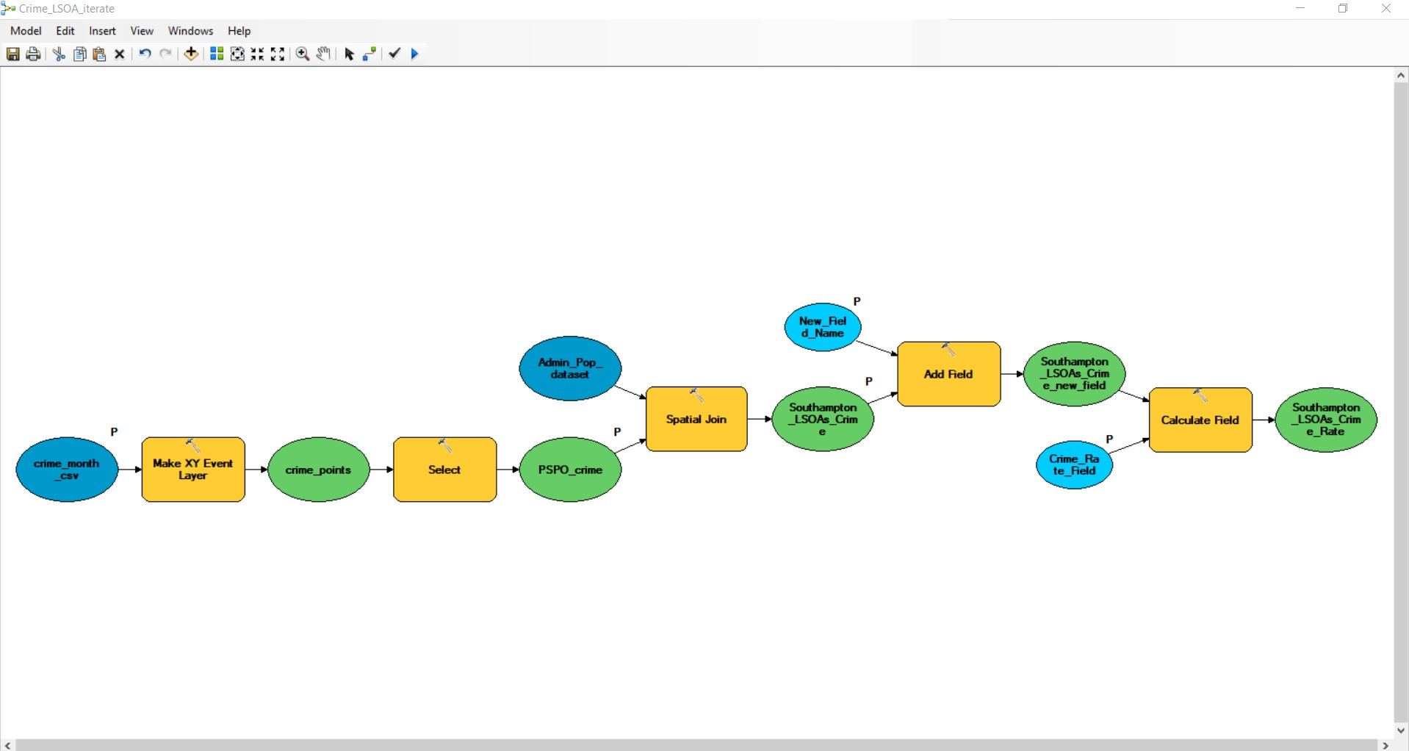

47. Once you’ve created these four Model Parameters, save the model, close the ModelBuilder window and re-open your model as a tool from the toolbox. Your tool should now look a little like this - note, yours will open with the April 2016 data already inserted and have Xs next to the PSPO_crime and Southampton_LSOAs_Crime variables as these dataset already exist. Have a go running the tool on another month’s dataset - remember to update the names and field (e.g. for June, just replace all the 4s with 6s).

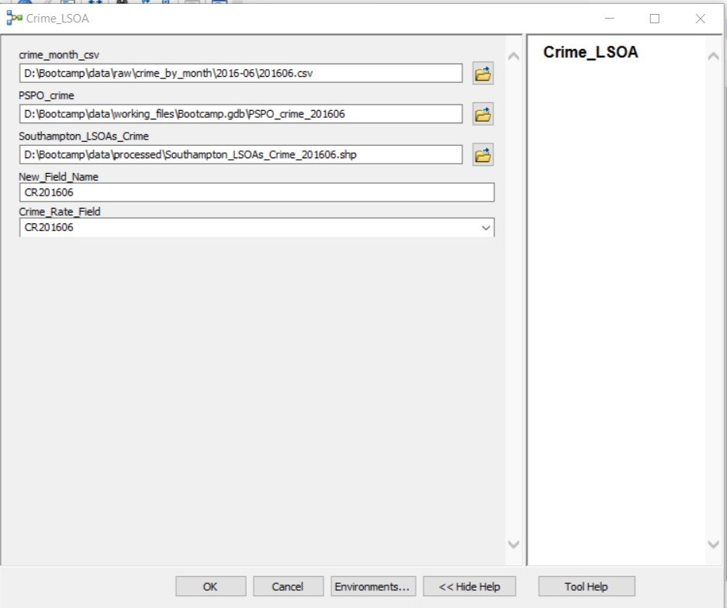
Note how when updating our paths to the June dataset, our variable names still make sense. Our variable names reflect what sort of data we are storing rather than the precise datasets.

48. Hopefully your tool should run successfully - and you should find your new shapefile added to ArcMap.

49. One thing you hopefully can notice, is that with our few edits renaming many of our variables, our tool was relatively easy to read. If we were to come back to the tool in a week or so, we’d know generally what we would need to set within our tool. Hopefully you get the idea why it’s important to rename your variables to something that is descriptive.
50. Furthermore. whilst this is a quick introduction to how you can use ModelBuilder into creating a tool within ArcMap, the parameters you have set would also be parameters you’d need to think about if you were to write this processing up as a function. For example, if we created a function called GetCrimeRate, we’d want to pass in the parenthesis the Input Dataset, the Output Dataset, the New Field Name and the Field for Calculation. In Python, we could clean up this last part of our model by setting the variable Field for Calculation equal to the New Field Name - something we will actually do in our script later on today.

Part Five: Using Iterators and Loops in ModelBuilder

Creating a tool from a model has many benefits - it’s visual, easy to document and share with others, and of course, you can process all six datasets with probably around 80% fewer clicks. (Alright, that’s just an estimate, but think about how much easier it was to just change the end number on our tool, then to run each process on every single CSV). The problem is, this still involves - in our opinion - way too much effort on our behalf.

In our case, when we want to process several CSVs in one go, it would be so much easier to have all this data ingested automatically - as part of the tool. And there is a way forward where we wouldn’t even need to edit the names and field columns ourselves.

The next step towards proficiently using ModelBuilder to automate your GIS processing is to understand how to use another fundamental concept within programming, Looping, and it’s compadre, what we will call here, Variable Substitution.

Looping

Looping, in its simplest understanding, is the repetition of processing according to the presence of objects within a sequence (of objects). What this means is that a process will loop over each object within this sequence. For example, if you were to loop through the string “FOUR”, where each character within the string equal one object, the process would loop four times (for F, for O, for U and for R). Another example is to loop through a list, where each item in the list equals one object. Other ‘loopable’ objects in Python include tuples, dictionaries and a set. Don’t worry about these for now, as we’ll be dealing with them on Day Three..

Variable substitution

Variable substitution is a little harder to explain without providing you with actual Python code. What essentially it allows you to do, is for each Object that you loop over, the value of that Object becomes a variable in its own right and can then be used within the code. For example, if we were to loop over our string “FOUR”, each loop would store a different letter as the value of our variable. What we can do with this is ask our computer to become a Vowel Detective - and only print Objects that are vowels found within the string. What the computer would do is for the first loop, store the Object (“F”) and then use it within our Vowel Detective Test code (we’ll use this as an example on Day Three.!). If it fails our code, then the computer won’t print the Object (“F”). The computer then starts the loop again, resets and stores our variable to the next Object (“O”) and then uses this within our code. This Object will pass our Test code and so the “O” will get printed. The loop then continues through the next two objects, resetting and storing the variable to the next Object.

Iterators

Fortunately for us, ModelBuilder gives us a really quick way to get used to using Loops and a similar method of Substitution. Within the ModelBuilder environment, the looping functionality are built into different types of Iterators. These iterators are built to loop over different aspects of a GIS project, from datasets to feature classes to the individual rows within a dataset. The list of iterators available in ModelBuilder are listed below, courtesy of Esri’s Help Documentation:

Iterator | Description
For | Iterates over a starting and ending value by a given value. It works exactly like For in any scripting/programming language, executing through a set number of items.
While | Works exactly like 'while' in any scripting/programming language, executing "while" a condition is true or false for the input or set of inputs.
Iterate Feature Selection | Iterates over features in a feature class.
Iterate Row Selection | Iterates over rows in a table.
Iterate Field Values | Iterates over each value in a field.
Iterate Multivalue | Iterates over a list of values.
Iterate Datasets | Iterates over datasets in a Workspace or Feature Dataset.
Iterate Feature Classes | Iterates over feature classes in a Workspace or Feature Dataset.
Iterate Files | Iterates over files in a folder.
Iterate Rasters | Iterates over rasters in a Workspace or a Raster Catalog.
Iterate Tables | Iterates over tables in a workspace.
Iterate Workspaces | Iterates over workspaces in a folder.

Iterators can be used to iterate an entire model, or for just one tool. One issue with these iterators however is that only one iterator can be used per model. If you need to iterate over more than one aspect, you will need to look at using nested models. You’ll be glad to know, we won’t be looking into this today!

Just like with our other geoprocessing tools, each iterator comprises of several parameters - for each, you’ll need to state the Input (e.g.a workspace, folder, files, dataset etc), declare any constraints or conditions (e.g. iterate over only shapefiles within this folder or only datasets starting with ‘2016’) and tell the iterator whether to look in subfolders (recursive). The Iterator will then provide one or two outputs, including the respective ‘Object’ it is iterating over and either the Name or Value of this object (if applicable). The table below, from the Esri Help Documentation summarises what to expect from each.

Iterator | Input | Output 1 | Output 2
For | Values | Value | -
While | Values | Boolean (True or False) | -
Iterate Feature Selection | Features | Feature | Value
Iterate Row Selection | Table | Record | Value
Iterate Field Values | Table | Field Value | -
Iterate Multivalue | Values | Value | -
Iterate Datasets | Workspace or Feature Dataset | Dataset | Name
Iterate Feature Classes | Workspace or Feature Dataset | Feature Class | Name
Iterate Files | Folder | File | Name
Iterate Rasters | Workspace or Raster Catalog | Raster Dataset | Name
Iterate Tables | Workspace | Table | Name
Iterate Workspaces | Folder | Workspace | Name

Each parameter is a type of variable. See the example given below provided by Esri for iterating over Feature Classes within a Workspace or Feature Dataset in ModelBuilder and think about which of these parameters are Data Variables and which are Value Variables:

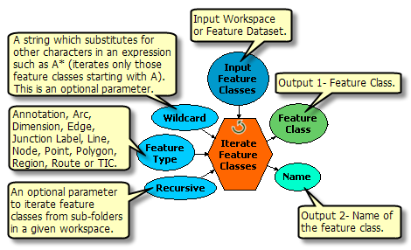

Thinking through these different variable types, you might notice in the table above that for all those iterators that have a Data Variable as a first Output, the second Output is a Value Variable. (In comparison, those iterators with a Value Variable as their first Output only have this one output.) The provision of this second Value Variable, which if you recall can be an actual value (e.g. returning the Value of a specific Feature using the features selection iterator) or a string (e.g. returning the Name of the dataset or file). Note in the latter, only the name is returned, not the full path to the respective dataset, file, table, workspace etc.

It is this second Output that can be incredibly useful when using loops to utilise a specific capability in-built into ModelBuilder called Inline Substitution.

Inline Substitution and Loops

In ModelBuilder, a variable can be used as a substitute within the contents of a part of a whole other variable (i.e. a parameter within the tool, such as a Dataset path, a Select Query, a Field Name etc.).

Whilst Inline Substitution can be used at any time within the model, the ability to substitute is incredibly useful when using Iterators or loops, particularly when it comes to naming conventions or using conditional statements.

For example, using the case of the Iterate Feature Classes above, our second output is a Value variable called ‘Name’. The variable itself stores the name of the dataset the iterator is currently looping through. So if we were to iterate through our crime data, the first dataset the Iterator would come across is our 201604.csv. Whilst the dataset itself would be the contents of the Output 1 variable, the Output 2 variable, Name, would store the name of the dataset as a Value, which is “201604” (i.e. a string). We then can use this variable in another process. Take the next step in our model, Make XY Event Layer, which requires us to give the temporary layer a name. Here we can provide the tool with the Name variable, written in the box as %Name%, and when the tool is run, it will fetch the actual value of the Name variable and substitute %Name% with this Value, which is the string “201604”. The layer will then be called 201604, or if we wanted we could add some further text in addition to our variable.

Inline substitution is actually really simple - but it’s probably easier to see it in action to get to grips with it. As you might guess, we’re actually going to be using it in our next bit of processing, so if its not clear hopefully going through the following exercise will make it so!

P.s. Other advanced capabilities in ModelBuilder (Not Covered Here!)

In addition to Iterators and Inline Substitution, there are many more advanced topics that you can delve into with Model Builder, including some Model-Only Tools, the use of Feedback loops, using Preconditions (to control the order of operations in a model), If-then-else logic to create a multiple processing options within a model (determined by fulfilling different conditions) and also learning how to write data only to memory and not file. We won’t be covering these topics here as we just don’t have enough time, but you can (and should) look into them if you end up finding ModelBuilder to be a really useful tool.

Step Three: Calculating Crime Rate in Southampton LSOAs (ModelBuilder - Intermediate)

Let’s get started with using our new found knowledge of Iterators and In-Line Substitution to get our Model to ingest and process our data automatically.

1. First delete any data created during the previous processing session - check your Processed folder and then your Geodatabase.

2. Open your Crime_LSOA model in the ModelBuilder window (remember to use the Edit option). Save your Crime_LSOA model as a new model under ‘Crime_LSOA_iterate’.

3. Remove the model parameter options from the input and output datasets and the field names.

Choosing our Iterator

We have folders of crime csvs that we want to automate the processing of – including the reading in, mapping, joining and then filed calculating and finally writing out to a new dataset. To do this we need to be able to iterate or loop over each csv and run the model we’ve just created. Fortunately ModelBuilder has an Iterator that allows us to do just that: Iterate Tables.

4. Click Insert → Iterators → Tables to insert out Iterator. The iterator should appear with two outputs: Table (Output 1) and Name (Output 2).

5. To be able to connect our Iterator to our model, we first need to delete our original input variable. This will turn (nearly) our entire model white. We then need to set the parameters for our iterator.

6. Open the Iterate Tables iterator tool. We want to set the Workspace to the folder which contains the tables we want to iterate over. We want to set this to the crime_by_month folder within our raw data folder. As we know our folders only contain one type of table (csv) and it's the table we want, we can leave the wildcard and table type options blank. We do however want our iterator to be recursive i.e. to go into the subfolders. As you should be aware, each of your crime csvs is stored in an individual folder - this option of being recursive allows us to leave the csvs in their individual folder. Without it, we’d need to copy all our csvs over into one single folder. Make sure you tick the Recursive box. Then click OK.

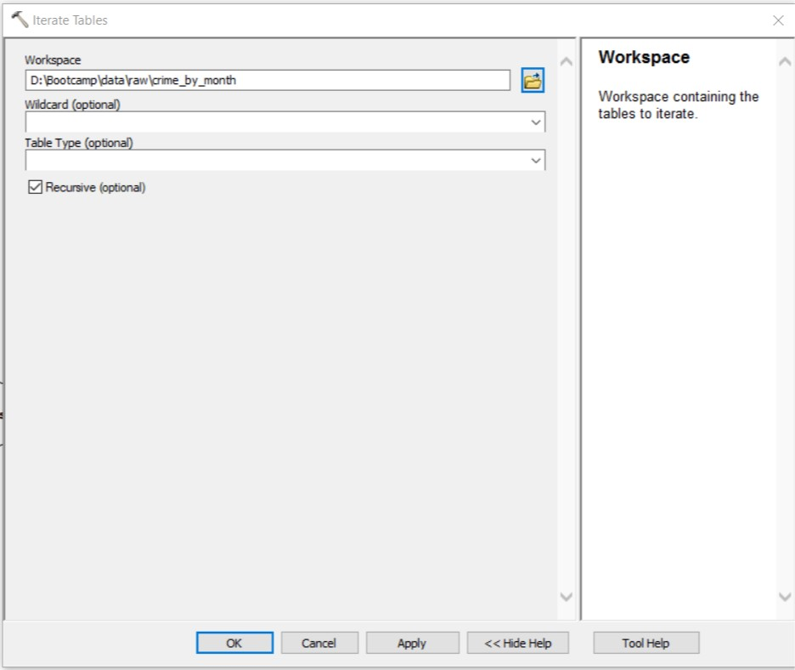

7. Our iterator is now ready to connect to our model, starting with connecting the Table output to the Make XY Event Layer tool. From reading the information above on Iterators and checking the table, we know that the Table output is the data variable which represents each Table the tool iterates over. We therefore need to connect the Table output to the tool as the Input XY Table (just as you did with the original April CSV). Click the Auto-Layout button to get the model to line up nicely.

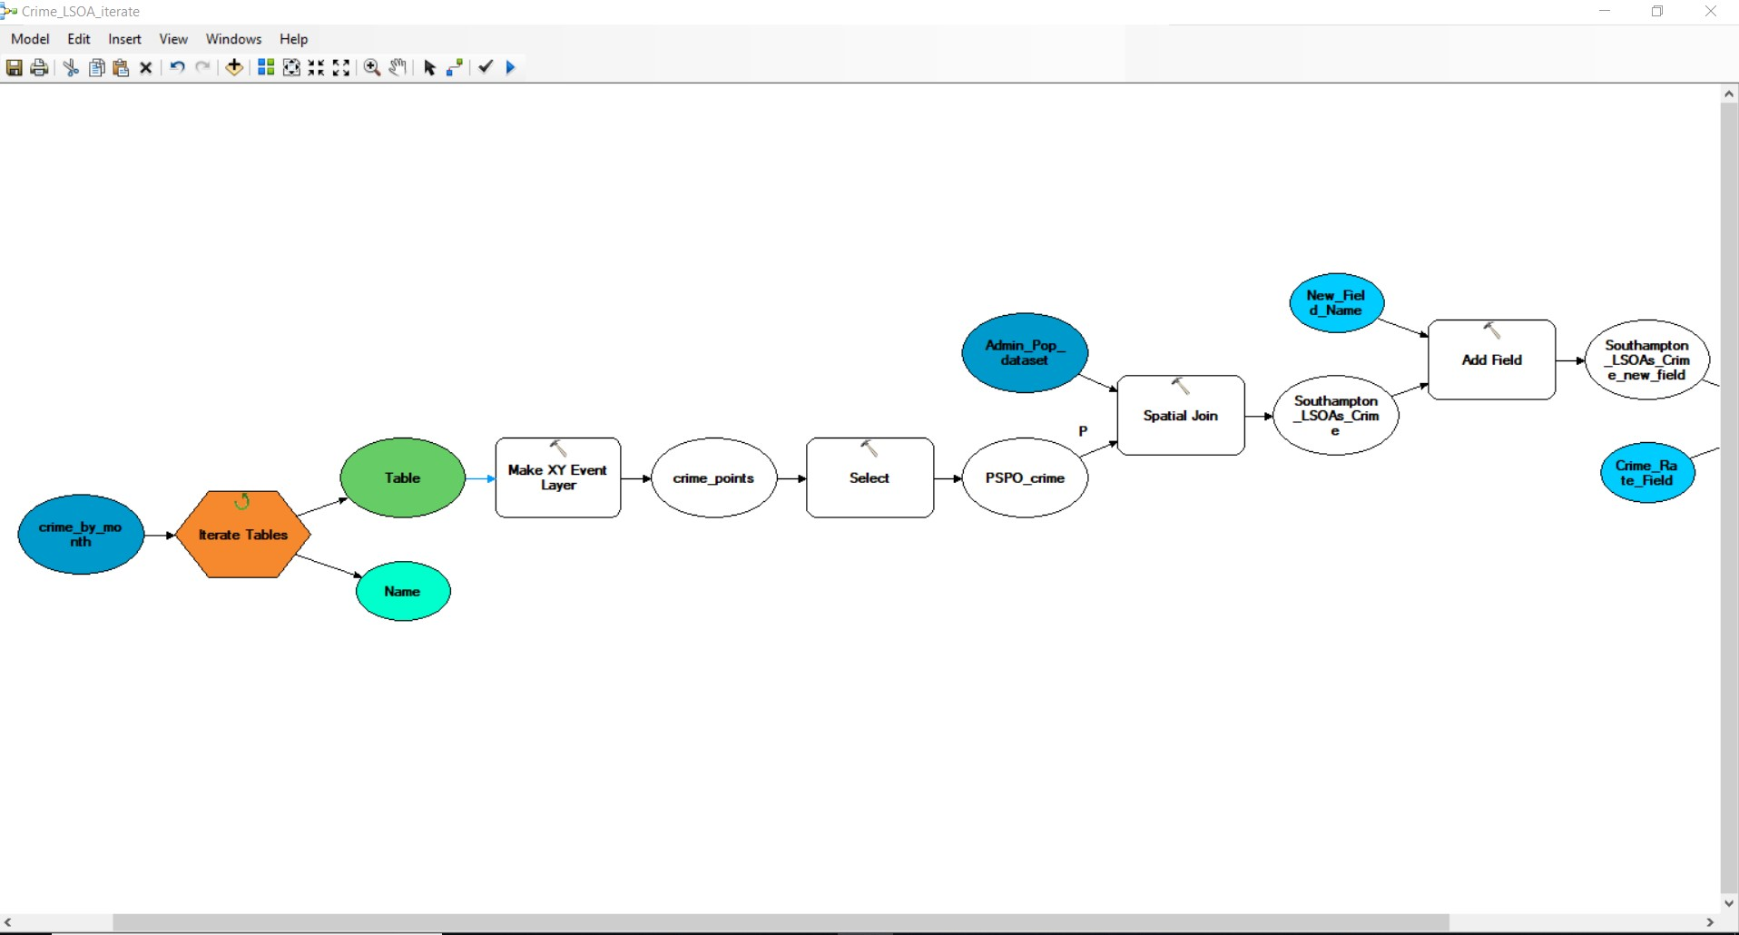

8. As you can see, despite connecting our new iterating input, the model is still not ready to run. We need to investigate each tool to see if and where parameters are missing.

9. Open the Make XY Event Layer tool. Straight away we can see the neither the X or Y Fields are populated, whilst the Layer Name is not going to work if we’re processing multiple datasets from different months.

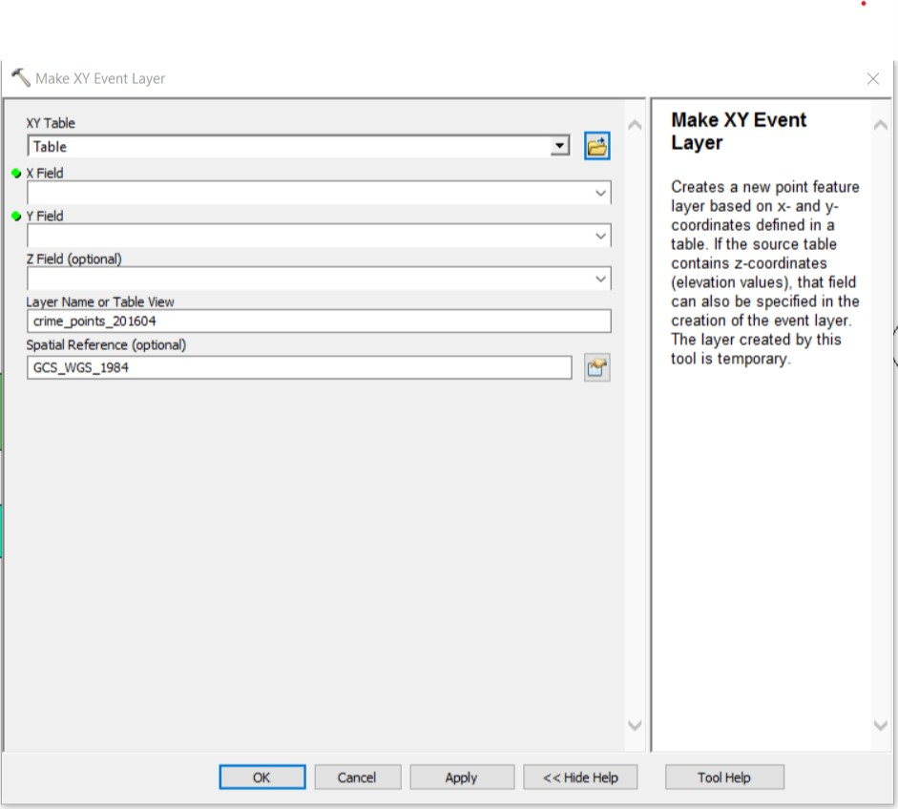

10. We can first address the Layer Name as we’ve already learnt a little about Inline Substitution. As we found out, the second output from Iterate Tables, Name, is a variable that stores the name of the table. Not only does it store the name of the table, but we can use this variable within our model to ultimately substitute in this name.

11. Within the Layer Name Field, change the 201604 suffix to %Name% (Remember, the % signs signify to ModelBuilder that this is a variable and not simply another piece of text). What this will do is when for example, the June 2016 table is loaded in, its name is stored as 201606 under the variable Name. Therefore whenever %Name% is used, 201604 will be substituted in! As a result, our layer will actually be called crime_points_201606 - and this will update for each csv, e.g. July and crime_points_201607, August and crime_points_201608 etc. Make sure you understand this as we’ll be using the Name variable can be used throughout our model.

12. We’ve addressed the issue of our Layer Name, now we need to focus on our X and Y Fields. The bad news is that we don’t seem to have an available X or Y Field from the drop down menu - this is because the model hasn’t loaded up the csv into its memory yet so is not sure what exact columns it will have to populate these fields. So we need to tell it. Whilst a quick and easy way would be to write in the Field names directly in the tool, we’re going to add more robustness to our model by creating Value variables that contain our X and Y Fields which are then passed into these X and Y Fields in the parameter boxes within our tool. This means if the field names change within the csv, all we need to do is reflect these changes in the variables, rather than open and edit the whole tool. For now click OK. to get back to the main ModelBuilder window.

13. Go to Insert and Create Variable. A pop-up should open. As you can see, there’s lots of different options you can set your variable type to; for us, we want to set our variables as a field, so scroll down to find the Field option and click OK.

14. A new variable shape called Field should pop up in your model window. We want to set the value of this variable Field to the name of one of the two columns we’ll be using for the X and Y Fields. As we know from cleaning our data (and already using it today!), there is a high level of standardisation within the data provided by data.police - and we know pretty confidently that each csv will contain two columns, one titled Latitude (containing our latitude coordinates) and one titled Longitude (containing the longitude coordinates!). We can therefore set our Field variable to one of these headers. Double click on the Field variable and write in ‘Longitude’. Note the capitalisation of the L - you need to make sure your variable value is an exact copy to ensure that the value of our variable corresponds with the fields that will be loaded up when the csv are read. Click OK. The shape should turn blue.

15. To make things a little easier for us, right-click on your Field and rename your variable to X Field. We now want to connect our X Field variable to our Make XY Event Layer tool and set it as the value of the X Field parameter.

16. Repeat the process for Latitude by creating a Y Field variable to be passed into the Y Field parameter.

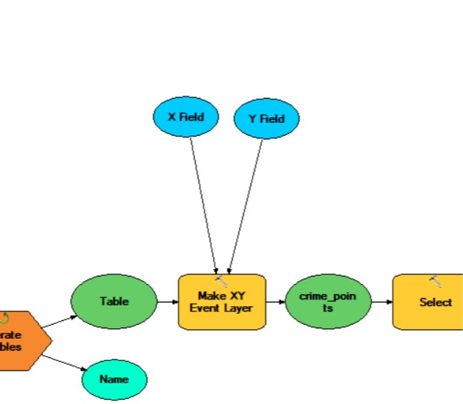

17. Now if you double click on our Make XY Event Layer tool, you should see the X and Y Field parameters populated with our X and Y Field variables.

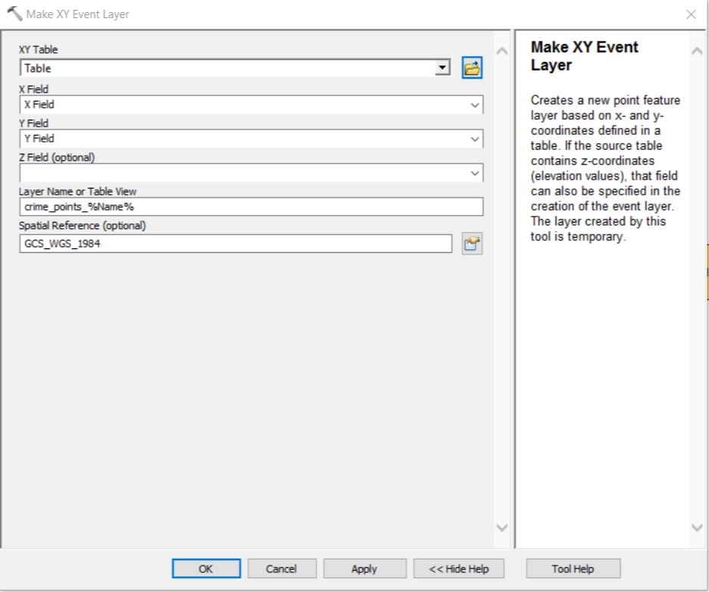

This use of a variable within a parameter is one of the most common ways you’ll see variables used within programming; for example, we’ll often write out a function with all of its parameters set as variables that will be already defined earlier in our script. Conversely, we can also use variables as parameters in functions that are in For loops, that update for each loop, using the Variable Substitution mentioned above. Don’t worry - you’ll get to grips with this shortly. Already, we’ve used variables within other parameters in our model (e.g. the new Field Names). As a result, there’s a lot more to using variables as parameters that we’ll cover - and you’ll be able to see some similarities between this and Esri’s ‘Inline Substitution’...

18. We can now move onto checking our next tool. Open up the Select tool. Here we need to make another Inline Substitution using our Name variable. What do you think you need to replace?

19. Once you’ve made your substitution, we can move onto the next tool, the Spatial Join. As you should be aware, the Spatial Join produces our final output -as a result, we need to make sure that each shapefile that is created from our model has a different name, and one that reflects the input data. Again, we only need to make one (similar) Inline Substitution. Be careful with your editing - and make sure your data will still be exported as a shapefile.

20. We now want to make sure any changes we make to this final output again reflect the original data it was created from - there’s not much point having a Crime Rate column called 201604 when we’re dealing with data from May? We therefore need to make two further Inline Substitutions - and it works exactly the same whether used directly within a tool or within a variable that is passed into the tool. We’ve already created a variable that stores the value of what our new field name will be which is then passed into the Add Field tool - so think about where do we need to make the substitution? Again, like the X and Y Fields, we could remove this variable and simply write the substitution in the tool but by using a variable we create more robustness within our model - when we get back to scripting, you’ll see exactly why we want to use variables within our parameters that can be easily reset rather than editing the tool itself. In fact, it would be good practice to create variables for all of our parameters that we’d edit, such as the names for our exported datasets but, for now, we don’t really have enough time to do so.

21. With the update of the Field Name to reflect the month and year of the csv being processed, we need to then reflect this change in Field used for the Calculate Field tool. Again we already have a variable that is passed into this parameter - so think about where you should make your final inline substitution.

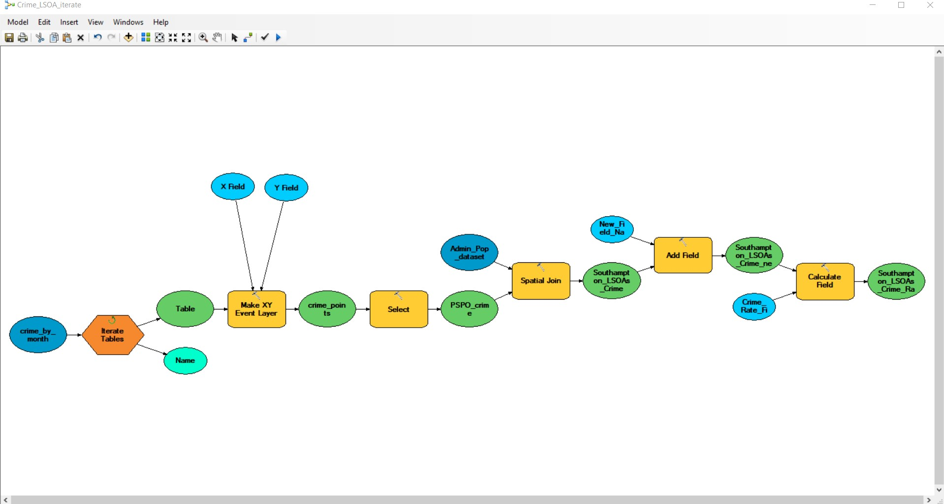

22. And that’s all there is to it! We’ve asked our model to (a) automatically ingest all tables within our crime folder, and (b) for each of these tables, run the processing that we’ve already tried and tested, but to make small changes in names and fields to reflect the year and month for that table.

23. Go ahead and save your model and then validate it. As long as you have no issues, you’re ready to run. Fingers crossed it works ; ) ! What should happen now is your model will look in your set folder within the Iterator and run the model automatically on all six csvs. Within a minute or so, you should have all six csvs processed and added to your processed folder! Open each up and check that not only do you have a crime rate column for each, but that this column is named after their respective month and year.

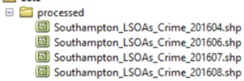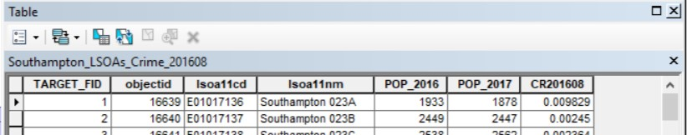

And that’s it. That is our SIX csv processed and ready for analysis. Whilst it has taken us a while to get to this point, think about how quickly you’d be able to repeat this processing for a similar set of data, whether using some commands within the console or by using ModelBuilder. Not only have we managed to automate the processing of the data but also its ingestion as well - and make sure this all gets saved in a recognisable and readable way.

The problem is, we currently have our processing in two different forms - our steps from yesterday were written up in ArcPy commands for the console, whilst this morning, we have only used ModelBuilder to create our workflow and run our processing. In addition, we’re not quite happy with our final output - we have six shapefiles each containing the same data, apart from ONE column which has our Crime Rate for that month.

It would be great if we could have figured out a way to have all six columns created within one single shapefile within the same model - but (and if you figure out a way to do this, please let us know!) as far as we can tell with our own knowledge and experience with ModelBuilder, we’re unable to feed our Southampton_LSOAs_crime_rate shapefile back into the process on each loop. Even if we figured this bit out, we’d also need to think about other bits of processing we’d need to do, such as dropping the Join Count column on each loop (to stop this creating a bug within the loop - ArcMap will complain that the field already exists), as well as adding in Steps 1 and 2 into our model. We managed to find a work around, that as you can see next in the Extension Activity involves creating another iterative model.

Whilst this all should be possible with ModelBuilder, the one thing we do know is that it’s possible - and rather easy - to do so within Python. And as we’re here to learn how to programme, it makes more sense to translate our current model into a Python script (along with adding in Steps 1 and 2) to bring all of our processing together. So once we’re back from our lunch - that’s what we’re going to do.

Extension Activity: Joining Crime Rate columns into a single shapefile using ModelBuilder

Ok, so we couldn’t figure out how to bring all six columns together within our Crime_LSOA_Iterate model, but - and as you’ll find with programming and automation, and GIS in general - we found a workaround that works well enough for us. To do so, we’ve needed to use a few extra capabilities of ModelBuilder and created a second model, Crime_LSOA_extension, shown in the screenshot below.

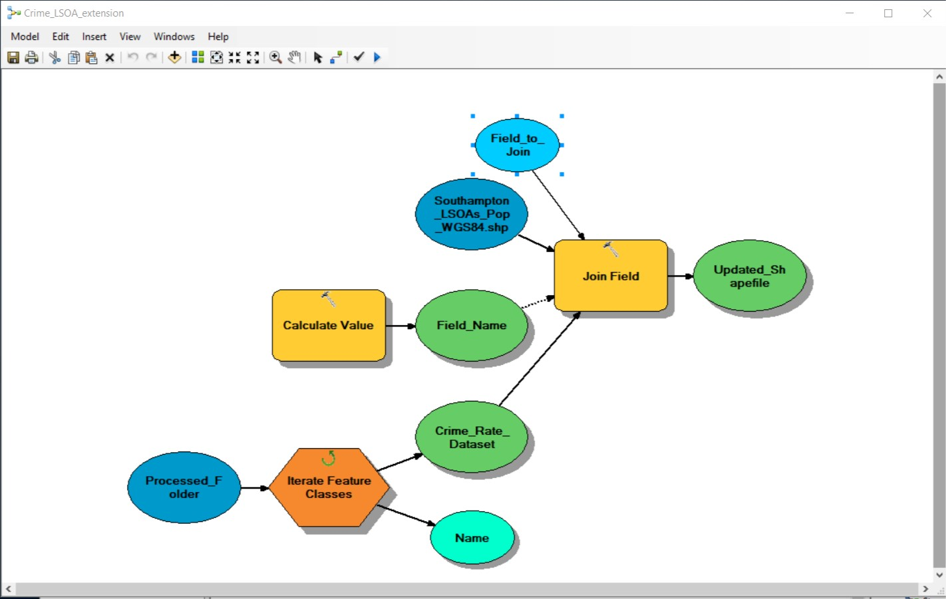

We’re not going to ask you to make the model but rather ask you about your interpretation of what the model does. We have a sheet up at the front which has the answers - but one way of checking your answers is to actually try to create the model yourself. For the new aspects of model builder you haven’t yet come across, we’ve provided links to the help documentation provided by Esri.

(1) What is the Data Variable Output of our Feature Classes Iterator:

(2) What is the Value Variable Output of our Feature Classes Iterator (write out an example):

(3) What type of join does Join Field provide: Permanent or Temporary?

(4) Which dataset is our input table for our Spatial Join?

(5) What type of connector is the output of the Calculate Value tool?

(6) The Calculate Value tool calculates a value based on an expression provided (in Python) to the tool. In our case, we provide the expression: %Name%[24:] to the tool. What would be output of the tool, stored as the variable Field_Name, for the Southampton_LSOAs_Crime_201607.shp? (Have a look at: https://developers.google.com/edu/python/strings to work out what our expression means).

(7) Our Value Variable, Field_to_Join, stores the value CR%Field_Name% . Using your output to Question 6, what would be the output from this variable for the Southampton_LSOAs_Crime_201607.shp?

(8) How is the Field_to_Join variable used within our Join Field tool?

Remember to pick up the answers - it also provides an explanation behind the connector choice for the Calculate Value tool, and why we needed to use this tool in the first place!

If you do want to have a go at making the model yourself, make sure to make a copy of the Southampton_LSOAs_Pop_WGS84 shapefile - and use this copy in your model.

Part Six: Scripting and the IDLE Programming Environment

We have now learnt the basics of using ArcMap and its geoprocessing tools within ArcPy and the Python console, and how to create an extensive workflow using ModelBuilder.

We’ve edited and written a little bit of code but we haven’t managed to consolidate everything we’ve done so far into one single workflow. Our next step therefore is to bring all of our workflow together under one script.

We however won’t be using the Python Console. It is pretty small and not that user-friendly to use and as a result, it’s easy to accidentally run code or type mistakes, and pretty annoying to edit with. Furthermore, there’s no direct way of saving your code - you’ll need to export it to a new file and keep track of any changes you make, either in your file or in the console.

To be able to write code proficiently, we’re going to use something that looks like a text editor (e.g. Notepad) but has a lot more going on behind the scenes than just processing words. We will use an Integrated Development Environment (IDE) to create Python files (with a .py extension), known as scripts, that can either be copied into the Python Console in ArcMap or executed from your computer (we’ll get into this in a bit).

Moving from short lines of code and from ModelBuilder will mean we have to make some edits from our original script. You’ll also see that any of the processing this morning, when copied as a python snippet, looks a bit different to the code that appears when you drag and drop the code into the console - and this is because the scripts predominantly use variables within the function’s parameters.

We’ll also run into a major issue when it comes to the repeated processing of the crime csvs. As Esri states, “If a model containing an iterator is exported to a Python script, the script will not include the iteration logic.” The iterators included in the ModelBuilder are specific to ModelBuilder and cannot be written out directly into a script or used within ArcPy.

Whilst we’re unable to use our Iterator tools in our script, we can use our understanding of how and why we’ve used them as a precursor to understanding the use of a Python Loop. Now we’re moving into using ArcPy and scripting, we will instead utilise another programming technique called Python listing logic which, in conjunction with using a Loop, will achieve the same repetition of processing.

Integrated Development Environments

ArcGIS software comes within a basic Python editor known as IDLE. IDLE has two windows - one for creating the script, and a second interactive window that, like the Python console, allows for the execution of code, including any scripts you may write. The output of running any of your scripts will appear within this interactive window, such as the printing of statements.

The reason why we want to use an IDE over a simple text editor is that it will provide lots of functionality that will help us write our code. At a minimum, a good IDE will:

- Have an editor that offers code completion (e.g. finding functions within a library or completing path names)
- Have an editor that offer syntax highlighting (i.e. colours your code according to whether it is a string, a function or an operator)
- A code explorer for functions (like the console in ArcMap, providing a pop-up with the parameters/arguments that the function expects)
- Tools to help with testing and debugging (i.e. if a script does not run, suggesting why and where a bug may be)

As we’ll be switching between ArcMap and IDLE for the rest of the afternoon, we’ll first spend a little time becoming familiar with the scripting window and the console window.

Getting familiar with our IDE: IDLE

1. Open IDLE - you can find it from the Search bar or find it within the ArcGIS application folder.
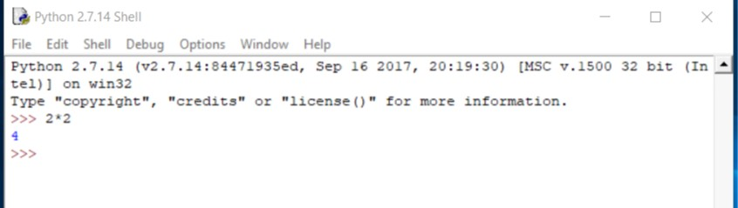
2. The first window that will load up is the IDLE Shell. You should recognise the prompt >>> sign appearing, which means you can right and execute code from this line. In this window, we can run simple lines of commands (just like in the Python console in ArcMap) or execute a script. For now, type in 2*2 and press return.
3. You should see the number 4 returned to the screen. Now type in the command print(“Hello World”). Press return.
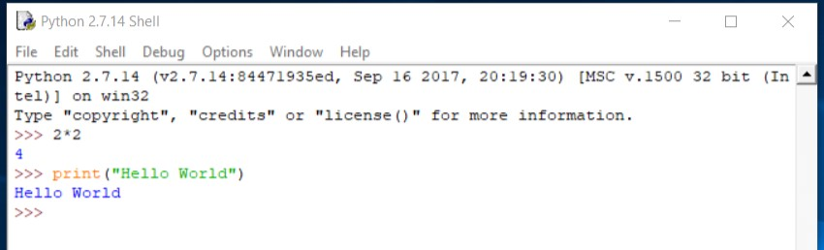
4. You should now see the string, Hello World, printed to the screen.
5. We could continue using the Shell to type in commands and execute code - but we would not exactly be improving on our previous option of using the Python console within ArcMap. We’re here to write a script - and to do so, we need to open the Scripting window.
6. From the Shell’s menu, click File → New File. A second window should appear. It looks different to the Shell - and does not have the familiar prompt >>> sign. We’re now in our scripting editor.
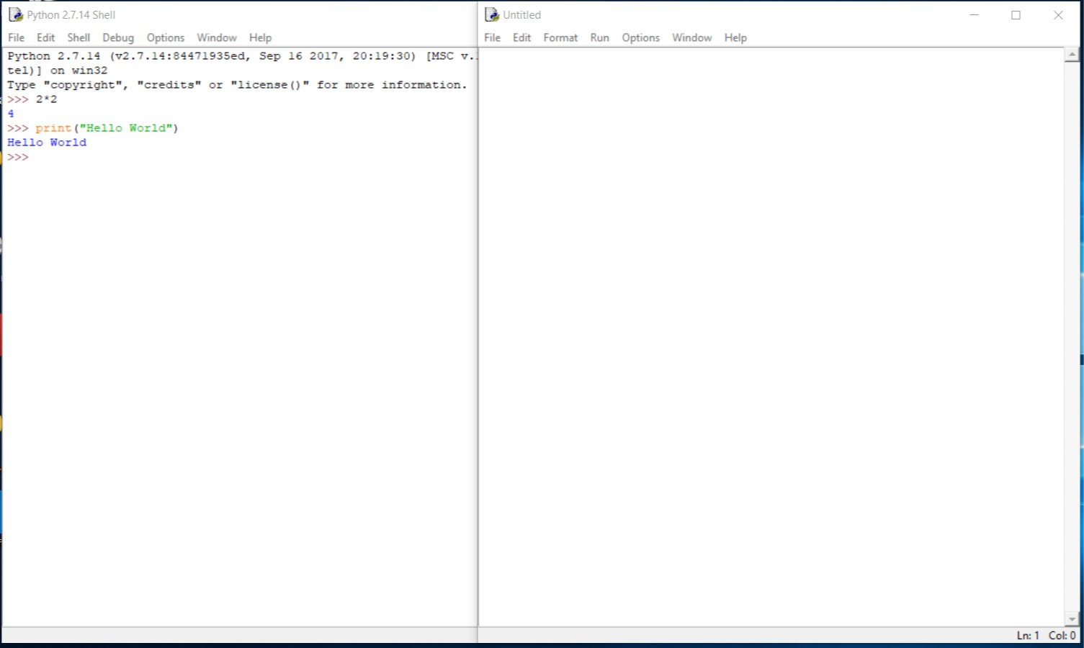
7. To see how these two windows work together, let’s just write out our print statement again. In the end, the printing of Hello World multiple times is a programming right of passage, so it only feels apt that we do it at least two times in this course.

8. So, in our scripting editor, write:
print(“Hello World”)
As you’ll see when you write your statement, the scripting editor will colour your code according to how it will interpret it. Generally, strings are in green, comments in red and any built-in python functions are orange.
9. We now need to save our file in order to run it as a script. Click on File → Save As and save your file in your src folder as helloworld.py . The.py extension should already be loaded in the Save as type option in the box, but just check to make sure.
10. We can now run our script. The easiest way to do this - and the only way we’ll be executing it today - is by running the script directly from the scripting window by clicking on Run in the menu bar and then Run Module. As you should see, the script then runs in the Shell and our string is printed to the screen.
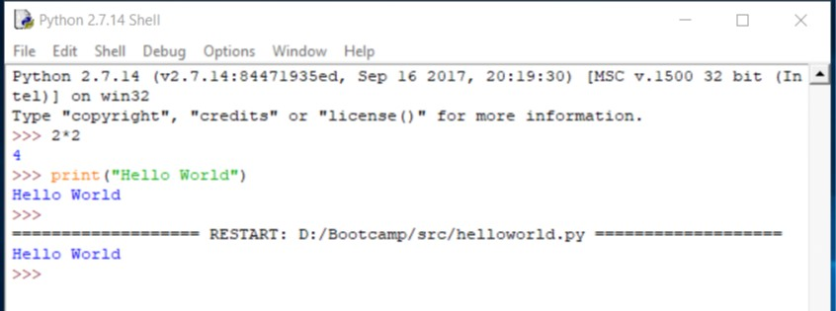
11. The quickest way to get your script to run is to use the keyboard shortcut, F5 (or FN+ F5 on some operating systems). If you end up closing your script, you can reopen it from the Shell by using File → Open. And it’s all as easy as that!
Initial Script Set-Up: Creating Good Habits
12. In the scripting editor, create a New File. Also close down your helloworld.py script so we don’t end up editing the wrong file.

13. The first thing we’re going to do to set up our script correctly is to begin documentation. Documentation is the most important aspect of writing a script - so it is good to get into practice writing comments as your write your code.

14. As you’ve already seen, there are lots of different aspects to code, from the functions and parameters to getting path names correct - and if you take a break from your code, even for example just to go on holiday, getting back into it can really be difficult, especially if you haven’t documented and commented your code and given yourself that helping hand. Today we’ll be making sure we comment our code, so if you decide to return to the project, you can understand the code pretty quickly.

15. To follow best practice, we want to see up our script first by using one or two lines at the start of the file to state what the script does and who has written it. Starting your code with an annotated description will help a lot when you have to look at or change it in the future - as well as save someone else a lot of time and effort if they come to use your code:

# This script processes the crime data for the SGP Bootcamp
# Written by your name
16. Let’s go ahead and save our script so it’s ready to run. Save your script as bootcampprocessing.py. It’s good to get this first initial save out of the way to make sure we have enough attention and patience to (a) save our scripts in the correct place and (b) have enough brain power left to call it something useful. We can then just use the standard Ctrl + S shortcut to save our work from now on.

17. Next, we can add some structure to our script by using comments to outline the different processing steps we want to cover in this script. Providing this structure can help break down our code into more manageable chunks rather than feeling like we need to write it out all in one go! Even if we hadn’t run the processing as we have already, using our methodology flowchart, we would know which steps we want to include and in which order. As a result, it is really useful to plan out your methodology and code beforehand. We can use double-hashes as bullet points, to create sub-sections within each of our steps:

# This script processes the crime data for the SGP Bootcamp
# Written by Joanna Wilkin

# Creating our population data admin shapefile

## Select required LSOAs from England and Wales LSOA raw file

## Adding population fields from 2016 and 2017 pop csvs to LSOA file

# Creating our crime rate data
18. Before we can start to code, we also need to think about the dependencies our code is likely to need. What this means is we need to consider what libraries we will use in our code - and then import these libraries to our scripts. You’ll tend to find that with most scripts, any library dependencies are stated at the top. As libraries are a two step process - first you must have the library installed on the machine you are running the script on and secondly, you must import that library into your script - it is best practice to have this dependency stated at the start so if you share your script with someone else, they can check straight away whether they need to install any of these libraries to get your script to run.

Already we know we’ll be using the ArcPy library and so we want to import this within our script as soon as possible. Note how we use a comment to create a new section, Required libraries - you can add to this import section as you develop your code.

# This script processes the crime data for the SGP Bootcamp
# Written by Joanna Wilkin

# Required libraries
import arcpy

# Creating our population data admin shapefile

## Select required LSOAs from England and Wales LSOA raw file

## Adding population fields from 2016 and 2017 pop csvs to LSOA file

# Creating our crime rate data

19. The final step to setting up your script is to consider whether you can declare any global variables. Global variables are variables that you are likely to use continuously throughout a script - and we’d only want to only wish to state once (important when it comes to writing loops and turning these into functions). Here we will set a global variable to the path of our data folder as we know we’re likely to have to type out this path over and over again.

Note: for the remainder of the Workshop, we will be using forward slashes instead of a backslash within our paths and the preceding r. It is easier to forget to use the r, rather than just stick to one convention - using forward slashes!
# This script processes the crime data for the SGP Bootcamp
# Written by Joanna Wilkin

# Required libraries
import arcpy

# Global variables
data_path = “H:/Bootcamp/data/”

# Creating our population data admin shapefile

## Select required LSOAs from England and Wales LSOA raw file

## Adding population fields from 2016 and 2017 pop csvs to LSOA file

# Creating our crime rate data

Again, we can add to this list as we develop our script and figure out what works best as a global variable and what works out better as a local variable i.e. is only required by certain functions or processing.
Let’s get scripting: Steps One and Two under one Python script

20. Now we have our script set up, we’re ready to start adding in our code. For the majority of your work outside the ArcPy workflow, this will require quite literally typing it all in from scratch. But, as we’ve already found, ArcMap and ArcPy can be incredibly useful in helping us get pre-written code. To get us started therefore, we’ll use our processing from this morning and a similar idea to the drag and drop process. This time, however, we want to right- click on the relevant process and copy it as a Python snippet.

21. Let’s get started and do this for our Select processing of the LSOA shapefiles. In ArcMap, navigate to your results window, find the relevant process (it should be in Previous Session → Yesterday) and Copy As Python Snippet.

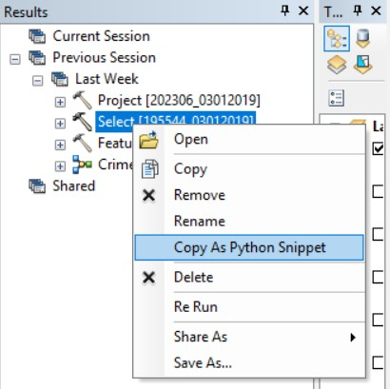

Note, if you haven’t been saving your .mxd as you’ve completed your processing - or lost your work due to ArcMap shutting down, you may not have this process saved in any results window. If not, you will need to copy the code over from the box below very carefully.

21. Paste your snippet underneath your ‘Select required LSOAs... ‘ comment.

# This script processes the crime data for the SGP Bootcamp
# Written by Joanna Wilkin

# Required libraries
import arcpy

# Global variables
data_path = “H:/Bootcamp/data/”

# Creating our population data admin shapefile

## Select required LSOAs from England and Wales LSOA raw file
arcpy.Select_analysis(in_features="H:/Bootcamp/data/raw/admin_boundaries/Lower_Layer_Super_Output_Areas_December_2011_Full_Clipped__Boundaries_in_England_and_Wales.shp", out_feature_class="H:/Bootcamp/data/working_files/Southampton_LSOAs.shp", where_clause='"lsoa11nm" LIKE 'Southampton%'')

## Adding population fields from 2016 and 2017 pop csvs to LSOA file

# Creating our crime rate data

You will need to use your arrow buttons to scroll back to the start or use the home shortcut (you may need to use Fn + Home). This is an annoying feature of IDLE, where there is no scroll bar to easily navigate your script - and one of the reasons why you’ll probably want to use a different IDE in the future!
22. As you can see, your code has copied over into a single line, which looks pretty similar to what we would have written up in the Python console. We can see that some of our parameters now consist of two components; the first stating what the parameter is (e.g. in_features) and the second, what the parameter is equal to (e.g. the data paths we are familiar with), and now looks like a variable. These are in fact written as keyword arguments (remember in Python, parameters are known as arguments).

Keyword and positional arguments in Python

When calling functions in Python, you’ll often find that your function has either keyword arguments or positional arguments. Keyword arguments are arguments that are explicitly defined, using expected_argument = . When arguments are defined using keywords, the order in which they are entered does not matter.

When we use keyword arguments:

- We can often leave out arguments that have default values.
- We can rearrange arguments in a way that makes them most readable.
- We call arguments by their names to make it more clear what they represent.
In comparison, positional arguments are not explicitly defined but they must be entered in a specific order for the function to pass them properly.

In some cases, you may find that a function takes a mixture of positional and keyword arguments - and this is why documentation is so important! Finding the documentation behind a function can let you know whether the arguments are keyword or positional, and if the former, how to define them, and if the latter, in which order to pass them.

23. In our case, we can actually check our Select documentation to see if these parameters actually require these keywords or not. See: http://desktop.arcgis.com/en/arcmap/10.3/tools/analysis-toolbox/select.htm and Esri’s own example below:

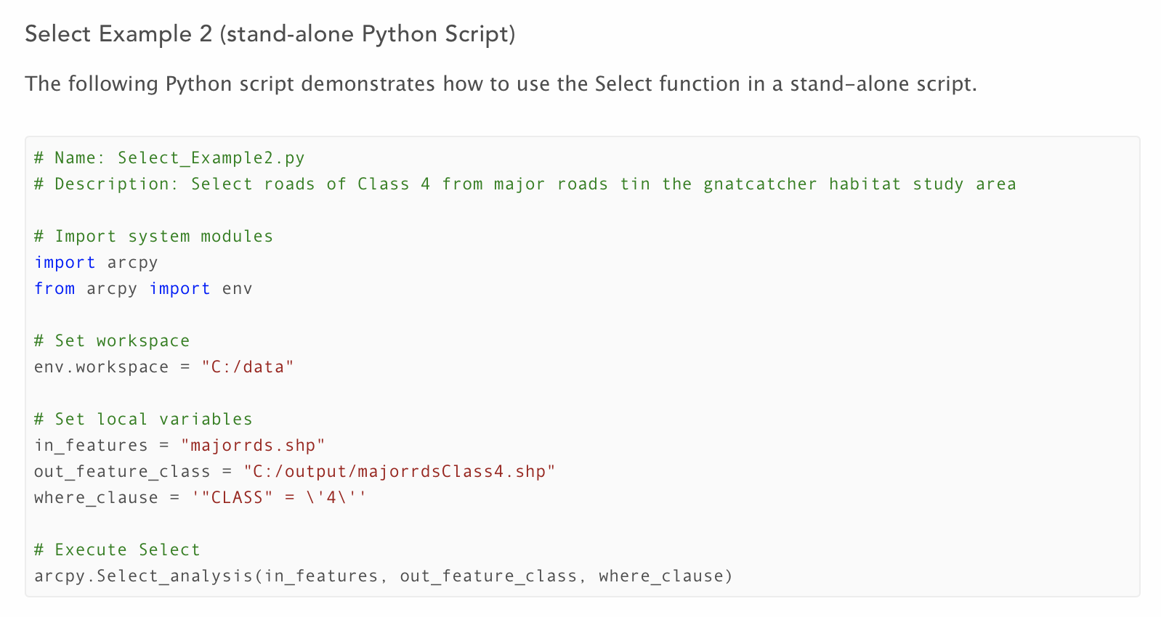

24. As we can see, we don’t actually need to include the keywords with our Select function - just keeping them in the right order will be sufficient for our function to run. However what we can see in Esri’s example is that the function itself is using variables for parameters, a practice we were using earlier on for some of our parameters in ModelBuilder.

25. Already we have the data_path variable which we could use to substitute for some of the path of both our in and out features, but we want to make our code even more robust by removing these paths from our function and, copying the example above, filling all of our parameters with variables.

26. Above your arcpy.Select function, add the three variables for our in_features, out_features and where_clause - but let’s call our variables something more descriptive to help with the legibility of our code:

# This script processes the crime data for the SGP Bootcamp
# Written by Joanna Wilkin

# Required libraries
import arcpy

# Global variables
data_path = “H:/Bootcamp/data/”

# Creating our population data admin shapefile

## Select variables
raw_lsoa_file =
southampton_lsoa_file =
lsoa_selection_query =

## Select required LSOAs from England and Wales LSOA raw file
arcpy.Select_analysis(in_features="H:/Bootcamp/data/raw/admin_boundaries/Lower_Layer_Super_Output_Areas_December_2011_Full_Clipped__Boundaries_in_England_and_Wales.shp", out_feature_class="H:/Bootcamp/data/working_files/Southampton_LSOAs.shp", where_clause='"lsoa11nm" LIKE 'Southampton%'')

## Adding population fields from 2016 and 2017 pop csvs to LSOA file

# Creating our crime rate data

Note how all of our variables are in lower case. It’s good practice to decide on a format for your variables and stick with it. Here we use lower case on every word and an underscore to separate words. Whatever you decide to use, just remain consistent with your variable formatting. This makes it easier for you to write your code as you won’t second guess your formatting. It also helps prevent small bugs - to use a variable in your code, it must be written exactly the same as how it was defined - even just a rogue Capital letter (or missing an ‘s’) will create a new variable and as a result, your variable will not be defined.
26. Now we have our Select variables ready, we need to (a) store the appropriate file paths and queries within them and then (b) replace our current parameters with these variables. To do so, we can copy and paste over the paths from our existing parameters - but also make several edits to utilise our global data_path variable.

27. For each file, we can remove ‘H:/Bootcamp/data/’ from the file path and replace it with data_path. We then use a + sign to join the variable and the remaining string together.

When used with strings, + signs are similar to the concatenate function in Excel, where, put simply, it joins two strings together, including when a string is stored within a variable.

Replacing part of our path with a variable will still output the same string, we just lower the chances of introducing bugs into our code by adding typos into our paths!
...

## Select variables
raw_lsoa_file = data_path + “raw/admin_boundaries/Lower_Layer_Super_Output_Areas_December_2011_Full_Clipped__Boundaries_in_England_and_Wales.shp”

southampton_lsoa_file = data_path + “working_files/Southampton_LSOAs.shp”
lsoa_selection_query =

...

Note, be careful with the use of forward slashes (/) and “”. If you look at your global variable, data_path, see how it ends in a / , this means you do not need to start your string with a / as we’re already looking within the data folder for the next directory. Also remember to keep the remainder of your file paths as a string (i.e. enveloped in “” ) and that they have .shp extension at the end.
28. We now want to make the where_clause a variable - but if we look at our current code, we can see straight away that there is an issue:

...

arcpy.Select_analysis(in_features="H:/Bootcamp/data/raw/admin_boundaries/Lower_Layer_Super_Output_Areas_December_2011_Full_Clipped__Boundaries_in_England_and_Wales.shp", out_feature_class="H:/Bootcamp/data/working_files/Southampton_LSOAs.shp", where_clause='"lsoa11nm" LIKE 'Southampton%'')

...

29. We know our where_clause needs to be an entire string to be passed by the Select argument. And thanks to our scripting editor and its colour coding, we can see that Southampton% is currently not being passed as a string. There is an issue with our current syntax - our strings are not being read due to escaping quotations. As a result, to prevent escaping quotations, we need to use one of the techniques mentioned earlier - either rei-introducing our escape character or using triple quotations. As we have our example from earlier, we will use our \ to stop our string from escaping. You may also need to change the single ‘ around the entire string to “:

...

arcpy.Select_analysis(in_features="H:/Bootcamp/data/raw/admin_boundaries/Lower_Layer_Super_Output_Areas_December_2011_Full_Clipped__Boundaries_in_England_and_Wales.shp", out_feature_class="H:/Bootcamp/data/working_files/Southampton_LSOAs.shp", where_clause="\"lsoa11nm\" LIKE 'Southampton%'")

...

30. We can now copy across the query to our new variable:

...

## Select variables
raw_lsoa_file = data_path + “raw/admin_boundaries/Lower_Layer_Super_Output_Areas_December_2011_Full_Clipped__Boundaries_in_England_and_Wales.shp”

southampton_lsoa_file = data_path + “working_files/Southampton_LSOAs.shp”

lsoa_selection_query = "\"lsoa11nm\" LIKE 'Southampton%'"

...

31. Now we have our variables declared, we now need to replace the parameters in our current Select function with our new variables. Make sure you add your variables in the correct order!

...

# Global variables
data_path = “H:/Bootcamp/data/”

# Creating our population data admin shapefile

## Select variables
raw_lsoa_file = data_path + “raw/admin_boundaries/Lower_Layer_Super_Output_Areas_December_2011_Full_Clipped__Boundaries_in_England_and_Wales.shp”

southampton_lsoa_file = data_path + “working_files/Southampton_LSOAs.shp”

lsoa_selection_query = "\"lsoa11nm\" LIKE 'Southampton%'"

## Select required LSOAs from England and Wales LSOA raw file

arcpy.Select_analysis(raw_lsoa_file, southampton_lsoa_file, lsoa_selection_query)

...

A quick note on ‘white space’ in terms of adding in lines between code - it’s up to you how you format the ‘breaks’ within your code i.e. adding in a line between variables or comments or functions. Do whatever makes it most legible for you - it does not affect the code. However, when it comes to white space in terms of the indentation of code, there are specific rules you must follow or else you will change the order your code is run. We’ll get to that later today and tomorrow.

32. Now we have our variables declared and function set with the correct parameters, we want to add in one final line of code that is used simply to help us understand whether the code has run or not. Obviously if the code is successful, a new file will be created - but, for example, if you were running this code on multiple files, it would require you to continually have to check. Instead, we can use a print statement to provide us with a simple message that the code has run - by putting the print statement below our function, it will only print if the print function has worked. This is a form of defensive programming. We can use this approach to test our script throughout its development to help use locate bugs . For example, if you’ve written a few blocks of code, you can add in print statements after each bit of processing to let you know (a) the code is running and (b) if it gets stuck, the last print statement will help you to figure out where. We’ll use this approach as we build our script.

33. Below your code, add our test in the form of a print statement. It can print whatever you like, but it’s probably most useful to tell us that the Select code has run and we have our selection. If our code is not successful - the print statement won’t work - if it is, we’ll get our print statement on our console window.

...

# Global variables
data_path = “H:/Bootcamp/data/”

# Creating our population data admin shapefile

## Select variables
raw_lsoa_file = data_path + “raw/admin_boundaries/Lower_Layer_Super_Output_Areas_December_2011_Full_Clipped__Boundaries_in_England_and_Wales.shp”

southampton_lsoa_file = data_path + “working_files/Southampton_LSOAs.shp”

lsoa_selection_query = "\"lsoa11nm\" LIKE 'Southampton%'"

## Select required LSOAs from England and Wales LSOA raw file

arcpy.Select_analysis(raw_lsoa_file, southampton_lsoa_file, lsoa_selection_query)

## Test that our Select function has run
print(“LSOA selection complete”)

...

34. We can now run our code and see if it works! But to us overwriting the data that we created yesterday (that we know has worked!), we’ll edit our output file to have _temp at the end of it just while we develop our script. To do so, you just need to edit the southampton_lsoa_file variable:

...

## Select variables
raw_lsoa_file = data_path + “raw/admin_boundaries/Lower_Layer_Super_Output_Areas_December_2011_Full_Clipped__Boundaries_in_England_and_Wales.shp”

southampton_lsoa_file = data_path + “working_files/Southampton_LSOAs_temp.shp”

lsoa_selection_query = "\"lsoa11nm\" LIKE 'Southampton%'"

## Select required LSOAs from England and Wales LSOA raw file

arcpy.Select_analysis(raw_lsoa_file, southampton_lsoa_file, lsoa_selection_query)

## Test that our Select function has run
print(“LSOA selection complete”)

...

35. Now, save your script (Ctrl + S) and then run it (Fn+F5).

36. Once it has run, you should have your print statement appear in the Shell. You can also check for the new file in ArcMap (remember to refresh your folder connection) and check that your new shapefile is correct. If you drag the shapefile onto your map canvas, you may get a warning about the coordinate system - which brings us to the next step in our script.

37. We now want to reproject the Southampton LSOA shapefile to match the CRS of the crime data - WGS84. Previously, we had done this after we had processed the population data, but it would be preferable to reproject the Southampton LSOA shapefile in its unedited form. This is just in case, for example, we find out a few weeks down the line that the population data was incorrect, we would only need to change this rather than also reproject the data as well.

38. If you can, find your projection result in the results window and copy again as a Python snippet. Paste this snippet below our select query.

...

## Test that our Select function has run
print(“LSOA selection complete”)

arcpy.Project_management(in_dataset=‘Southampton_LSOAs_Pop’, out_dataset=“H:/Bootcamp/data/working_files/Southampton_LSOAs_Pop_WGS84”, out_coor_system="GEOGCS['GCS_WGS_1984',DATUM['D_WGS_1984',SPHEROID['WGS_1984',6378137.0,298.257223563]],PRIMEM['Greenwich',0.0],UNIT['Degree',0.0174532925199433]]", transform_method="'OSGB_1936_To_ETRS_1989_1 + ETRS_1989_To_WGS_1984'", in_coor_system="PROJCS['OSGB_1936_British_National_Grid',GEOGCS['GCS_OSGB 1936',DATUM['D_OSGB_1936',SPHEROID['Airy_1830',6377563.396,299.3249646]],PRIMEM['Greenwich',0.0],UNIT['Degree',0.0174532925199433]],PROJECTION['Transverse_Mercator'],PARAMETER['false_easting',400000.0],PARAMETER['false_northing',-100000.0],PARAMETER['central_meridian',-2.0],PARAMETER['scale_factor',0.9996012717],PARAMETER['latitude_of_origin',49.0],UNIT['Meter',1.0]]", preserve_shape="NO_PRESERVE_SHAPE", max_deviation="", vertical="NO_VERTICAL")

...

39. Scroll back to the left hand side of the screen. Before we do anything, we’re first of course going to add in a comment above our code to help us out:

...

## Test that our Select function has run
print(“LSOA selection complete”)

## Reproject Southampton LSOA file from BNG to WGS84 CRS
arcpy.Project_management(in_dataset=‘Southampton_LSOAs_Pop’, out_dataset=“H:/Bootcamp/data/working_files/Southampton_LSOAs_Pop_WGS84”, out_coor_system="GEOGCS['GCS_WGS_1984',DATUM['D_WGS_1984',SPHEROID['WGS_1984',6378137.0,298.257223563]],PRIMEM['Greenwich',0.0],UNIT['Degree',0.0174532925199433]]", transform_method="'OSGB_1936_To_ETRS_1989_1 + ETRS_1989_To_WGS_1984'", in_coor_system="PROJCS['OSGB_1936_British_National_Grid',GEOGCS['GCS_OSGB 1936',DATUM['D_OSGB_1936',SPHEROID['Airy_1830',6377563.396,299.3249646]],PRIMEM['Greenwich',0.0],UNIT['Degree',0.0174532925199433]],PROJECTION['Transverse_Mercator'],PARAMETER['false_easting',400000.0],PARAMETER['false_northing',-100000.0],PARAMETER['central_meridian',-2.0],PARAMETER['scale_factor',0.9996012717],PARAMETER['latitude_of_origin',49.0],UNIT['Meter',1.0]]", preserve_shape="NO_PRESERVE_SHAPE", max_deviation="", vertical="NO_VERTICAL")

...

Your pasting of your snippet may have also brought across some comments from ArcMap telling you that the in features dataset, Southampton_LSOAs_Pop, is a layer within the table and not the actual file path of the dataset. As the instructions say, we need to replace this layer with the direct path of the dataset. This is because the Python console cannot read directly the layer names i.e. data loaded within ArcMap, as it is not connected to our .mxd document. Irrespective of this, we would want to make this script as autonomous as possible - to do so we want to store as many file paths as possible in variables that are then used within parameters.

40. Once again, we can see that ArcPy has added in the named parameters/arguments. We can double check the documentation for Project and see if they are required (http://desktop.arcgis.com/en/arcmap/10.3/tools/data-management-toolbox/project.htm)

41. As we can see from the examples provided in the documentation, we do not need to use the named parameters. We now can edit our script. We first want to set any required variables. Whilst we already have our input dataset set as a variable in our Select code (southampton_lsoa_file), we want to set the output dataset as a variable (southampton_lsoa_file_wgs84). Note, these file names are a little different to the code we’ve copied over because we ended up running the Project tool at the end of our processing, resulting us in running the code on our Southampton LSOA Population dataset. Here we’re running the code before the adding of the population data so we will be using the Southampton LSOA dataset. Also note wgs84 is in lower capitals this time.

...

## Reproject Southampton LSOA file from BNG to WGS84 CRS
southampton_lsoa_file_wgs84 = data_path + “working_files/Southampton_LSOAs_wgs84_temp.shp”

...

42. We can now replace our two named parameters with our variables within the code. For now, we will leave the code containing the CRS and transformations within the function. Explaining how to re-code properly this is a little more complicated than what we want to achieve today! Remember to add our test at the end of our function (it’s easy just to copy and paste your Select test and edit accordingly):

...

## Test that our Select function has run
print(“LSOA selection complete”)

## Reproject Southampton LSOA file from BNG to WGS84 CRS
southampton_lsoa_file_wgs84 = data_path + “working_files/Southampton_LSOAs_wgs84_temp.shp”

arcpy.Project_management(southampton_lsoa_file, southampton_lsoa_file_wgs84, out_coord_system="GEOGCS['GCS_WGS_1984',DATUM['D_WGS_1984',SPHEROID['WGS_1984',6378137.0,298.257223563]],PRIMEM['Greenwich',0.0],UNIT['Degree',0.0174532925199433]]", transform_method="'OSGB_1936_To_ETRS_1989_1 + ETRS_1989_To_WGS_1984'", in_coor_system="PROJCS['OSGB_1936_British_National_Grid',GEOGCS['GCS_OSGB 1936',DATUM['D_OSGB_1936',SPHEROID['Airy_1830',6377563.396,299.3249646]],PRIMEM['Greenwich',0.0],UNIT['Degree',0.0174532925199433]],PROJECTION['Transverse_Mercator'],PARAMETER['false_easting',400000.0],PARAMETER['false_northing',-100000.0],PARAMETER['central_meridian',-2.0],PARAMETER['scale_factor',0.9996012717],PARAMETER['latitude_of_origin',49.0],UNIT['Meter',1.0]]", preserve_shape="NO_PRESERVE_SHAPE", max_deviation="", vertical="NO_VERTICAL")

## Test that our Project function has run
print(“Reprojection complete”)

...

43. Before we can run the code, we need to delete our previously created temp dataset - or else our script will throw an error that the dataset already exists. This because the whole script runs each time we execute it.

The easiest way to do this is to use Catalog within ArcMap. Make sure you also remove it as a layer from the ArcMap Table of Contents as well as a dataset from Catalog. Refresh both the View and Catalog once deleted. You can now return to the scripting editor and run your script!

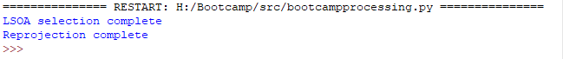

44. You should get your two print statements within the Shell to confirm that your code has run. Again you can check in ArcMap that the datasets exist and look appropriate (e.g. you can check the metadata of both to see that there are differences in their CRS.

45. Great - we can now move on to adding our population data to our newly projected Southampton LSOA file.

46. As we know from our processing earlier, we first need to copy our csvs into a feature class table to generate the OIDs required for the join. In ArcMap, find the CopyRows results, Copy As Python Snippet and paste over.

...

## Test that our Project function has run
print(“Reprojection complete”)

## Adding population fields from 2016 and 2017 pop csvs to LSOA file
arcpy.CopyRows_management(in_rows="H:/Bootcamp/data/working_files/lsoa_pop_2017.csv", out_table="H:/Bootcamp/data/working_files/Bootcamp.gdb/lsoa_pop_2017", config_keyword="")
...

47. The first thing we may notice is that we’re going to be using the same path over and over again - to our working_files folder. And if we quickly look through our other lines of codes, we do end up using this path a lot. So to help with tidying up a code even more, the first thing we will do is add in another path variable in the Global Variables section, so we can shorten even further our paths throughout our code.

48. Below the data_path variable, write:

...

# Required libraries
import arcpy

# Global variables
data_path = “H:/Bootcamp/data/”
working_files = “H:/Bootcamp/data/working_files/”

...

49. We can now substitute this variable through our code, for example:

...

## Reproject Southampton LSOA file from BNG to WGS84 CRS
southampton_lsoa_file_wgs84 = working_files + “Southampton_LSOAs_wgs84_temp.shp”

...

50. You’ll need to make two substitutions (1) the southampton_lsoa_file (not shown) and (2) the southampton_lsoa_file_wgs84 (shown above) variables. If you are unsure of what this means, please ask a demonstrator.

51. Now let’s get back to our CopyRows function. Now we have a more tidy way of accessing our datasets in the working_files folder, let’s create two variables to access our two population csvs. We can then follow up these with our output tables - remember they’ll be stored in the Bootcamp.gdb and to add the _temp suffix whilst we’re still testing our code.

...

## Test that our Project function has run
print(“Reprojection complete”)

## Adding population fields from 2016 and 2017 pop csvs to LSOA file
lsoa_pop_2016 = working_files + “lsoa_pop_2016.csv”
lsoa_pop_2017 = working_files + “lsoa_pop_2017.csv”

lsoa_pop_2016_gdb = working_files + “Bootcamp.gdb/lsoa_pop_2016_temp”
lsoa_pop_2017_gdb = working_files + “Bootcamp.gdb/lsoa_pop_2017_temp”
...

52. Before we edit our function, we should also check the documentation again to see if we need to retain our keyword variables: (http://desktop.arcgis.com/en/arcmap/10.3/tools/data-management-toolbox/copy-rows.htm).

53. As we don’t, we can substitute our parameters into our function. We can also help our future selves by adding in another comment about what this specific function does and add in another test print statement.

...

## Adding population fields from 2016 and 2017 pop csvs to LSOA file
lsoa_pop_2016 = working_files + “lsoa_pop_2016.csv”
lsoa_pop_2017 = working_files + “lsoa_pop_2017.csv”

lsoa_pop_2016_gdb = working_files + “Bootcamp.gdb/lsoa_pop_2016_temp”
lsoa_pop_2017_gdb = working_files + “Bootcamp.gdb/lsoa_pop_2017_temp”

### Copies csvs into GDB to provide OIDs, ready for joining
arcpy.CopyRows_management(lsoa_pop_2016, lsoa_pop_2016_gdb, "")
arcpy.CopyRows_management(lsoa_pop_2017, lsoa_pop_2017_gdb, "")

### Test that our CopyRows function has run
print(“Copies complete”)

...

Note, it is quite easy just to copy, paste and edit the majority of this code from 2016 to 2017 - you don’t have to write it all out again! But pay attention to all of the details and make sure you replace the years correctly - or else you may break the function.

54. Now we have our two csvs in the right format, we can now join them to Southampton_LSOA_wgs84 shapefile. Find the relevant JoinField process within ArcMap and Copy As Python Snippet. Again, we get the same warning about the use of layers but that’s ok, we have our variables ready and waiting!

55. As we’ve already got our input variables ready, we can actually go ahead and start with our parameter-variable substitution. Let’s start by checking the documentation and confirming we can remove the named parameters (http://desktop.arcgis.com/en/arcmap/latest/tools/data-management-toolbox/join-field.htm) and then go ahead with replacing them with the relevant variables for the each year.

...

### Test that our CopyRows function has run
print(“Copies complete”)

arcpy.JoinField_management(southampton_lsoa_file_wgs84, in_field="lsoa11cd", lsoa_pop_2016_gdb, join_field="LSOA_CD", fields="POP_2016")

...

56. As we can see, we’ll still have a couple of named parameters left in our code. And if we think about these named parameters, as two of them will be the same for each csv, we could turn them into variables.
...

### Test that our CopyRows function has run
print(“Copies complete”)
lsoa_field = "lsoa11cd"
table_field = "LSOA_CD"

arcpy.JoinField_management(southampton_lsoa_file_wgs84, lsoa_field, lsoa_pop_2016_gdb, table_field, "POP_2016")

...

57. We can now replicate the function for the other population dataset - in our case lsoa_pop_2017 - and we will need to only make two small character changes.

...
lsoa_field = "lsoa11cd"
table_field = "LSOA_CD"

arcpy.JoinField_management(southampton_lsoa_file_wgs84, lsoa_field, lsoa_pop_2016_gdb, table_field, "POP_2016")

arcpy.JoinField_management(southampton_lsoa_file_wgs84, lsoa_field, lsoa_pop_2017_gdb, table_field, "POP_2017")

...

58. Finally, let’s add our comment and test print statements to our function.
Note, if you end up encountering an error, an approach to finding out where it is is to add print statements under each JoinField function. This could tell you, for example, if it was just one of the csvs that was causing an issue e.g. that particular csv had not been cleaned correctly!
...

### Add population field from pop datasets to our shapefile

lsoa_field = "lsoa11cd"
table_field = "LSOA_CD"

arcpy.JoinField_management(southampton_lsoa_file_wgs84, lsoa_field, lsoa_pop_2016_gdb, table_field, "POP_2016")

arcpy.JoinField_management(southampton_lsoa_file_wgs84, lsoa_field, lsoa_pop_2017_gdb, table_field, "POP_2017")

### Test that our Join Field functions have run
print(“CSV fields joined to SHP”)

...

58. Now save your code! Before we run it, we need to make sure we remove any previously processed files from our folders (i.e. anything that ends in _temp) using ArcMap. For now, you should only need to check your working_files folder - but after running this code, you’ll also need to check the Bootcamp.gdb. Remember to remove any temp files from the Table of Contents, refresh your View and your Catalog Folder Connection. Now return to the scripting editor and run your code!
If you run into any problems, such as a message stating there is an existing lock, make sure you have refreshed our View on ArcMap and your Folder Connection - if it still doesn’t work, you’ll need to close and reopen arcmap! Yay! (Remember to save your .mxd!)

59. If your code has run successfully, you should now have several print statements appear in the Shell and the shapefile, Southampton_LSOAs_wgs84_temp.shp, should now contain population data.

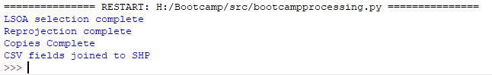

60. And that’s how we get our LSOA and population data processed using code alone. And it really wasn’t that hard - yes, we had most of the code written for us by ArcMap, but if you did spend time looking at the function documentation lists, it wouldn’t exactly be too difficult to get this code written ourselves without copying over the python snippets.

61. The next step is going to get a little more complicated as we introduce a few more programming concepts. Again, whilst we’re still learning, we’re going to get ArcMap to help us as much as possible. But by the end of this next set of steps, we will have three Extension Activities to challenge you to write your own scripts.

Step Three: Getting the basics right first

62. For now, save and close down your Bootcampprocessing.py . We’re currently happy with how this script works and we don’t want to inadvertently edit it or introduce bugs as we start adding more complexity when writing code for Step 3.

63. Return to ArcMap and find your Bootcamp toolbox. Open up the ‘Crime_LSOA’ model in the ModelBuilder window (using ‘edit’). Remove all of the model parameters and then save the model. Then go to Model → Export → To Python Script. Save within your src folder, calling it Crime_LSOA.py. Close the model.

64. Repeat the same process for the ‘Crime_LSOA_iterate’ model. (Note, you won’t have any model parameters to remove from this model). Close the model.

65. We have now exported both our models to Python scripts, which we can now go ahead and open them in IDLE. Put them side by side on your screen so we can compare.

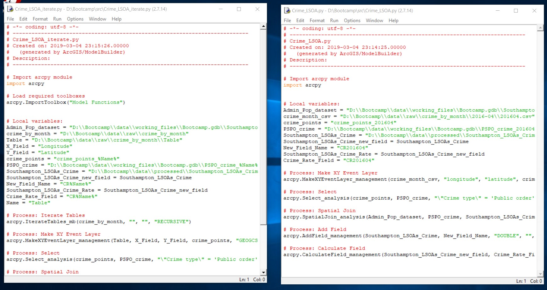

66. As you can see, there are several differences between the two scripts. For the Crime_LSOA_iterate.py script, we now import a toolbox called Model Functions (although this won’t work in Python!), have an extended list of local variables within which some of the common local variables between the two scripts store different values, and finally an extra process, called IterateTables (again, this will not work in Python).
67. As we know this iteration within the Iterate model will not work, using this script is probably not wise - we’d first have to work out what code we need to remove and the code we need to change before we even start to think about editing it, which could quite quickly lead to errors or bugs. As a result, we’re going to close down this script and focus on editing Crime_LSOA.py, where we’re looking to only add and edit code to get our iterative capabilities.

68. To begin with, we first need to figure out how to make our five processes work with our existing bootcamp script i.e. we need to get our variables right. Once we’ve managed to get this processing to work for one single file, then we can add in our loop. There’s no point perfecting our loop if the processing within it does not work or fulfil our requirements.

69. Open a new file in the scripting editor, and put it side by side with our Crime_LSOA.py script. Set it up as follows and save your script as stepthreetest.py. We’re going to use it as a playground (a common programming term used for experimental/draft code!) to build and test our code for bringing together all of our Step Three processing. As this is a separate script from our bootcampprocessing.py, we need to account for any potential dependencies again. This includes importing ArcPy and, in our case, as we’d like to use the path shortcut variables, adding these in as well.

# This script is a playground for testing out our Crime Rate generation code
# Written by Joanna Wilkin

## Required libraries
import arcpy

# Global variables
data_path = “H:/Bootcamp/data/”
working_files = “H:/Bootcamp/data/working_files/”

70. Below the Global Variables, copy across our first process - Make XY Event Layer.

...
# Process: Make XY Event Layer

arcpy.MakeXYEventLayer_management(crime_month_csv, "longitude", "latitude", crime_points, "GEOGCS['GCS_WGS_1984',DATUM['D_WGS_1984',SPHEROID['WGS_1984',6378137.0,298.257223563]],PRIMEM['Greenwich',0.0],UNIT['Degree',0.0174532925199433]];-400 -400 1000000000;-100000 10000;-100000 10000;8.98315284119522E-09;0.001;0.001;IsHighPrecision", "")

71. As you can see from our code (and checking the documentation), our function takes up to six parameters.

MakeXYEventLayer_management (table, in_x_field, in_y_field, out_layer, {spatial_reference}, {in_z_field})

72. We know that we haven’t used any of these parameters yet in our previous code, so we can set these variables directly within our process. Of course, we can use our data_path variable to set our path neatly. Our crime_points variable is only a temporary layer, so does not require a path - only a name - but let’s still add our _temp suffix whilst we’re still developing our code.

# Process: Make XY Event Layer

crime_month_csv = data_path + “raw/crime_by_month/2016-04/201604.csv”
x_field = “Longitude”
y_field = “Latitude”
crime_points = “crime_points_201604_temp”
CRS = "GEOGCS['GCS_WGS_1984',DATUM['D_WGS_1984',SPHEROID['WGS_1984',6378137.0,298.257223563]],PRIMEM['Greenwich',0.0],UNIT['Degree',0.0174532925199433]];-400 -400 1000000000;-100000 10000;-100000 10000;8.98315284119522E-09;0.001;0.001;IsHighPrecision"

arcpy.MakeXYEventLayer_management(crime_month_csv, "longitude", "latitude", crime_points, "GEOGCS['GCS_WGS_1984',DATUM['D_WGS_1984',SPHEROID['WGS_1984',6378137.0,298.257223563]],PRIMEM['Greenwich',0.0],UNIT['Degree',0.0174532925199433]];-400 -400 1000000000;-100000 10000;-100000 10000;8.98315284119522E-09;0.001;0.001;IsHighPrecision", "")

73. Now we have our variables written up, we need to substitute these into our parameters within the function. We can also remove the final parameter, z coordinates (currently stored as “”) as this is (a) optional and (b) we don’t have any coordinates to provide. Removing the parameter simply means that nothing will be provided in its place when the function is called.

# Process: Make XY Event Layer

crime_month_csv = data_path + “raw/crime_by_month/2016-04/201604.csv”
x_field = “Longitude”
y_field = “Latitude”
crime_points = “crime_points_201604_temp”
CRS = "GEOGCS['GCS_WGS_1984',DATUM['D_WGS_1984',SPHEROID['WGS_1984',6378137.0,298.257223563]],PRIMEM['Greenwich',0.0],UNIT['Degree',0.0174532925199433]];-400 -400 1000000000;-100000 10000;-100000 10000;8.98315284119522E-09;0.001;0.001;IsHighPrecision"

arcpy.MakeXYEventLayer_management(crime_month_csv, x_field, y_field, crime_points, CRS)

74. We can edit our comment to provide a little more description and also insert a print function test at the end of our function.

# Turn crime csv into temporary xy points layer

crime_month_csv = data_path + “raw/crime_by_month/2016-04/201604.csv”
x_field = “Longitude”
y_field = “Latitude”
crime_points = “crime_points_201604_temp”
CRS = "GEOGCS['GCS_WGS_1984',DATUM['D_WGS_1984',SPHEROID['WGS_1984',6378137.0,298.257223563]],PRIMEM['Greenwich',0.0],UNIT['Degree',0.0174532925199433]];-400 -400 1000000000;-100000 10000;-100000 10000;8.98315284119522E-09;0.001;0.001;IsHighPrecision"

arcpy.MakeXYEventLayer_management(crime_month_csv, x_field, y_field, crime_points, CRS, "")

print(“Points layer created”)

75. Instead of testing our code straight away, we’re going to get the rest of our processes/functions written up. If we ended up with an error, hopefully our print statements will help us figure this out - and we can get debugging once our script is complete.

76. Copy over the Select function from Crime_LSOA.py into the stepthreetest.py script.

...

print(“Points layer created”)

# Process: Select
arcpy.Select_analysis(crime_points, PSPO_crime, "\"Crime type\" = 'Public order' OR \"Crime type\" = 'Anti-social behaviour'")

77. We now have two variables to set - our exported dataset and our select query. We can use our already set crime_points variable within our function. Be careful with your naming of your selection variable - we already have a where_clause called lsoa_selection_query, so we definitely don’t want to use that! Also make sure your selection query is interpreted by the editor fully as a string i.e. all the text is green. If it is not, you may need to use several escape characters.

...

print(“Points layer created”)

# Process: Select

pspo_crime = working_files + “Bootcamp.gdb/PSPO_crime_201604_temp”
pspo_selection_query = "\"Crime type\" = 'Public order' OR \"Crime type\" = 'Anti-social behaviour'"

arcpy.Select_analysis(crime_points, pspo_crime, pspo_selection_query )

78. Once you’ve set your variables, edit your parameters in your Select function and then add in a test print statement as well as edit the description comment. Save your script.

...

# Extract only PSPO related crime and save within our gdb

pspo_crime = working_files + “Bootcamp.gdb/PSPO_crime_201604_temp”
pspo_selection_query = "\"Crime type\" = 'Public order' OR \"Crime type\" = 'Anti-social behaviour'"

arcpy.Select_analysis(crime_points, pspo_crime, pspo_selection_query)

print(“PSPO crime file created”)

79. Now copy over your SpatialJoin process.

...

print(“PSPO crime file created”)

# Process: Spatial Join
arcpy.SpatialJoin_analysis(Admin_Pop_dataset, PSPO_crime, Southampton_LSOAs_crime, "JOIN_ONE_TO_ONE", "KEEP_ALL", "objectid \"objectid\" true true false 4 Long 0 0 ,First,#,D:\\Bootcamp\\data\\working_files\\Bootcamp.gdb\\Southampton_LSOAs_Pop_WGS84,objectid,-1,-1;lsoa11cd \"lsoa11cd\" true true false 80 Text 0 0 ,First,#,D:\\Bootcamp\\data\\working_files\\Bootcamp.gdb\\Southampton_LSOAs_Pop_WGS84,lsoa11cd,-1,-1;lsoa11nm \"lsoa11nm\" true true false 80 Text 0 0 ,First,#,D:\\Bootcamp\\data\\working_files\\Bootcamp.gdb\\Southampton_LSOAs_Pop_WGS84,lsoa11nm,-1,-1;POP_2016 \"POP_2016\" true true false 4 Long 0 0 ,First,#,D:\\Bootcamp\\data\\working_files\\Bootcamp.gdb\\Southampton_LSOAs_Pop_WGS84,POP_2016,-1,-1;POP_2017 \"POP_2017\" true true false 4 Long 0 0 ,First,#,D:\\Bootcamp\\data\\working_files\\Bootcamp.gdb\\Southampton_LSOAs_Pop_WGS84,POP_2017,-1,-1", "CONTAINS", "", "")

80. We can replace our initial parameters in our SpatialJoin function relatively simply. Our first parameter is of course the population dataset we have just created in the bootcampprocessing.py script: southampton_lsoa_file_wgs84. We can enter the variable directly into the function, but as we’re currently in a different script, we need to - for now - define this variable within the SpatialJoin process. When have finalised this script, we will need to copy it over into bootcampprocessing.py and remove this variable duplication.

81. We can then add the output variable of our Select function, pspo_crime, as our join features within the SpatialJoin function.

82. We then need to declare a variable for the output of the Spatial Join, let’s call it southampton_lsoas_crime for now and make it equal to the path, data_path + “processed/Southampton_LSOAs_Crime_201604_temp.shp”. (Check your capitalisation versus non-capitalisation here!)

83. We can then add variables for our join_operation and join_type, as well as match_option parameters. Store the respective values, “JOIN_ONE_TO_ONE”, “KEEP_ALL” and “CONTAINS” within these variables. We can then remove the two optional variables at the end of the function.

...

print(“PSPO crime file created”)

# Process: Spatial Join

southampton_lsoa_file_wgs84 = working_files + “Southampton_LSOAs_wgs84_temp.shp”
southampton_lsoas_crime = data_path + “processed/Southampton_LSOAs_Crime_201604_temp.shp”
join_operation = "JOIN_ONE_TO_ONE"
join_type = "KEEP_ALL"
match_option = "CONTAINS"

arcpy.SpatialJoin_analysis(southampton_lsoa_file_wgs84, pspo_crime, southampton_lsoas_crime, join_operation, join_type, "objectid \"objectid\" true true false 4 Long 0 0 ,First,#,D:\\Bootcamp\\data\\working_files\\Bootcamp.gdb\\Southampton_LSOAs_Pop_WGS84,objectid,-1,-1;lsoa11cd \"lsoa11cd\" true true false 80 Text 0 0 ,First,#,D:\\Bootcamp\\data\\working_files\\Bootcamp.gdb\\Southampton_LSOAs_Pop_WGS84,lsoa11cd,-1,-1;lsoa11nm \"lsoa11nm\" true true false 80 Text 0 0 ,First,#,D:\\Bootcamp\\data\\working_files\\Bootcamp.gdb\\Southampton_LSOAs_Pop_WGS84,lsoa11nm,-1,-1;POP_2016 \"POP_2016\" true true false 4 Long 0 0 ,First,#,D:\\Bootcamp\\data\\working_files\\Bootcamp.gdb\\Southampton_LSOAs_Pop_WGS84,POP_2016,-1,-1;POP_2017 \"POP_2017\" true true false 4 Long 0 0 ,First,#,D:\\Bootcamp\\data\\working_files\\Bootcamp.gdb\\Southampton_LSOAs_Pop_WGS84,POP_2017,-1,-1", match_option)

84. We’ve now hit our first real coding snag. Our parameter, field_mapping, controls what attribute fields will be in the output feature class. If we look at the documentation it tells us that the default, i.e. if we left this parameter empty, is that all fields would be joined. Whilst this could be an option if we were not comfortable with coding up our fields, it does create extra work for us, working out how to delete all the fields we don’t need after joining the data. As a result, it would be really useful to use the field_mapping parameter.

However, the content of current field_mapping parameter included within our SpatialJoin code is not really suitable for us to use moving forward, as it doesn’t easy allow us to edit the fields we may want to keep or remove.

Instead, we’re going to need to use some more complex code that we aren’t quite ready for: however, by tomorrow, you certainly will be. As a result, the code you need to copy across is written out below - commented up to explain what each line does. If it ends up making sense, then that’s great but we’ll also come back to this code tomorrow morning and delve a little deeper into it! To save you from having to copy this line for line (and potentially making a mistake), you can find the code written up in the fieldmapping.py script within you src folder.

## Create our list of fields using the Field Mapping objects

### Declare a variable equal to the function arcpy.FieldMappings
fieldmappings = arcpy.FieldMappings()

### Add the fields from the tables of our two datasets to our variable
fieldmappings.addTable(southampton_lsoa_file_wgs84)
fieldmappings.addTable(pspo_crime)

### Create a list of the fields that we want in our final shapefile, southampton_lsoas_crime
fields_to_keep = ["FID", "lsoa11cd", "lsoa11nm","POP_2016", "POP_2017"]

### Remove any fields in our field mappings that are not in our fields_to_keep list
#### For each field in the fieldmappings fields
for field in fieldmappings.fields:
#### if the field name of that field is not in the list of fields to keep
if field.name not in fields_to_keep:
#### then remove that field from our fieldmappings fields
#### Note, the code in the parenthesis uses the field name to search the Field Map
Index and locate the entire column that we want to remove
#### This is then passed to the function ‘removeFieldMap’, to remove this Field
fieldmappings.removeFieldMap(fieldmappings.findFieldMapIndex(field.name))

### Set a variable to the output of our fieldmappings process, i.e. a field map of the fields we want to keep
fields_to_join = fieldmappings

85. You’ll need to copy the above code from the fieldmapping.py script and paste it below your other variables (and before the SpatialJoin process).

Make sure to update the respective parameter within the SpatialJoin code - you’ll need to delete all of the green text and then add in instead the variable fields_to_join. Also remember to edit our description comment and add a test print statement. Overall, your SpatialJoin code should look a little like this:

...

# Join our point data to our LSOA Pop file, keeping only certain fields
southampton_lsoa_file_wgs84 = working_files + “Southampton_LSOAs_wgs84_temp.shp”
southampton_lsoas_crime = data_path + “processed/Southampton_LSOAs_Crime_201604_temp.shp”
join_operation = "JOIN_ONE_TO_ONE"
join_type = "KEEP_ALL"
match_option = "CONTAINS"

## Create our list of fields using the Field Mapping objects

### Declare a variable equal to the function arcpy.FieldMappings
fieldmappings = arcpy.FieldMappings()

### Add the fields from the tables of our two datasets to our variable
fieldmappings.addTable(southampton_lsoa_file_wgs84)
fieldmappings.addTable(pspo_crime)

### Create a list of the fields that we want in our final shapefile, southampton_lsoas_crime
fields_to_keep = ["FID", "lsoa11cd", "lsoa11nm","POP_2016", "POP_2017"]

### Remove any fields in our field mappings that are not in our fields_to_keep list
#### For each field in the fieldmappings fields
for field in fieldmappings.fields:
#### if the field name of that field is not in the list of fields to keep
if field.name not in fields_to_keep:
#### then remove that field from our fieldmappings fields
#### Note, the code in the parenthesis uses the field name to search the Field Map
Index and locate the entire column that we want to remove
#### This is then passed to the function ‘removeFieldMap’, to remove this Field
fieldmappings.removeFieldMap(fieldmappings.findFieldMapIndex(field.name))

# Set a variable to the output of our fieldmappings process, i.e. a field map of the fields we want to keep
fields_to_join = fieldmappings

# Run the spatial join function
arcpy.SpatialJoin_analysis(southampton_lsoa_file_wgs84, pspo_crime, southampton_lsoas_crime, join_operation, join_type, fields_to_join, match_option)

print("Spatial Join complete")

...

86. Now we have all of our parameters set for our SpatialJoin, we can move on to our last two processes.

87. Copy and paste over the AddField process from Crime_LSOA. Here we only need to create two variables: 1) a variable for the new field name, crime_rate_field (remember to store the value as “CR201604”) and 2) a variable for the field_type (“DOUBLE”). Edit the respective parameters within the AddField function and remove the optional parameters (ie. all those after field_type). Add our test print statement and comment.

88. The final process to copy over is our CalculateField. Here we can substitute our second parameter with the crime_rate_field variable we just created.

89. The final variables to create are to do with our calculation. The first variable to create is crime_rate_calculation and to store our calculation within this variable. Whilst we originally entered this in Visual Basic in our model, we’re going to re-write this calculation in Python. For Python calculations, the field names must be enclosed in exclamation points rather than square brackets (!fieldname!). Make sure to edit our original calculation appropriately - and ensure that it is still stored as a string.

90. We’ll also need to make a variable called expression_type and set it to “PYTHON” (this variable tells ArcGIS what language the calculation is expressed in). Remove any optional parameters.

91. Finally, add our test print statement and comment.

92. These last two blocks of code should look like this:

...

# Add our Crime Rate field to our final shapefile

crime_rate_field = "CR201604"
field_type = "DOUBLE"

arcpy.AddField_management(southampton_lsoas_crime, crime_rate_field, field_type)

print("Field Added")

# Calculate Crime Rate within the Crime Rate field

crime_rate_calculation = "!Join_Count! / !POP_2016!"
expression_type = "PYTHON"

arcpy.CalculateField_management(southampton_lsoas_crime, crime_rate_field, crime_rate_calculation, expression_type)

print("File processing complete")
Obviously your description comment and print statement can be a little different!

93. And that’s it! We now have all five processes of Step 3 written up as ArcPy code. It’s taken a little longer than using ModelBuilder - mainly made complicated by the fieldmapping code. Unfortunately, this often occurs in programming - you’re trying to do something that at first should be relatively simple but then appear issues that you just haven’t accounted for! If this happens, and you get stuck, there are multiple sources of help, from searching online to asking a competent friend or a colleague.

94. Before we can run our script, make sure to save it. Once run, you should end up with the print statements appearing in the Shell - and our data appearing in the relevant folders.

95. As long as this happens, you’re ready to move onto the adding in our loops to create our iteration - and automatically ingest and process the remaining csvs!

96. You can also now close the Crime_LSOA.py script as we’ll no longer be needing this.

Part Seven: Listing logic and Loops in ArcPy Python Scripts

We now have our single csv processing written up in a script - but as we’re aware, we need to apply this script to five other csvs. To do so, we can finally get to adding in our loop to automate the ingestion and processing of these csvs.

Creating a for loop that ingests datasets within Python is a two step process - first, we need to provide our for loop with a list of the datasets that we want it to loop through. Then we run our loop on this list. To build a list requires some sort of cataloging function - a method of finding the dataset or object that you’re interested in and then adding it to a list. Fortunately, in ArcPy, there are some automated tools that will do this cataloging for us - we just have to learn how and where to use them (a bit like learning about the Iterators earlier today).

Generating Lists in ArcPy: Existing Cataloging Tools

ArcPy has a number of functions that have been built specifically for creating different types of lists. This can include lists of datasets; feature classes; files; rasters and tables, to name some of those you’re most likely to use in the near future. These functions are detailed below, from Esri’s Help documentation:

List Function | Content of list returned
ListFields(dataset, wild_card, field_type) | Returns a list of fields found in the input value
ListIndexes(dataset, wild_card) | Returns a list of attribute indexes found in the input value
ListDatasets(wild_card, feature_type) | Returns the datasets in the current workspace
ListFeatureClasses(wild_card, feature_type, feature_dataset) | Returns the feature classes in the current workspace
ListFiles(wild_card) | Returns the files in the current workspace
ListRasters(wild_card, raster_type) | Returns a list of rasters found in the current workspace
ListTables(wild_card, table_type) | Returns a list of tables found in the current workspace
ListWorkspaces(wild_card, workspace_type) | Returns a list of workspaces found in the current workspace
ListVersions(sde_workspace) | Returns a list of versions the connected user has permission to use
The type of data returned by the list will be determined by the content returned. For example, for those returning a dataset or file, a string will be returned that contains the path to the dataset or file.

For the ListFields and ListIndexes functions, the dataset will need to be specified that needs to be iterated through.

For the majority of the other ListFunctions, the functions will iterate by default through the current workspace that are defined in the environment settings. The current workspace is usually the workspace from which inputs are taken and outputs are placed when running tools, e.g. the set default geodatabase. However, it may be the case that your current workspace does not equate to where your data of interest* is stored. (*i.e. what you want to build a list from).

As a result, when using these ListFunctions, it is important to set the workspace environment within your script before using the function to the folder that holds your data of interest.

This is a limitation of these functions in that they can only look within the current workspace (i.e. folder). As a result, if you want to use multiple functions within the same script that will look into different folders, you’ll need to reset the current workspace for each function. (To clarify, the workspace environment must be set first before using: ListDatasets, ListFeatureClasses, ListFiles, ListRasters, ListTables and ListWorkspaces.)

Each of the functions take similar parameters, most of which we have encountered before. All functions have a wildcard parameter which can be used to restrict the objects or datasets listed by name. In this scenario a wildcard will define a name filter and all the contents in the new list must pass this filter. In addition, several of the functions have the _type parameter that requires the contents to match certain data properties, such as a .shp file instead of a .geojson; or polygons only, no points.

For example, to use the ListFunctions we would simply write out this code, which would then provide us with a list of the files, stored as the variable, Files, which we can then iterate through using a for loop.

import arcpy

# Set our workspace to our folder of interest

arcpy.env.workspace = "path_to_folder"

# Equate the output of our List function to a variable

Files = arcpy.ListFiles()

For Loops: Syntax and Substitution

You’re about to become very very familiar with for loops, so to ensure you find them as simple as possible, we’re going to address the syntax and substitution upfront.

All for loops start with the same opening statement:

for loop_variable in our_list:

The opening statement translates as, for each item in our list. It always requires:
- Opening for command
- Then a variable to store each item we’re going to iterate over in our list
- This is what we’ll call the loop_variable - you can use any* word to represent you loop_variable and as evident, does not require a = after it to state that it is a variable.
- You’ll commonly see the use of a single letter (e.g i) within other people’s code, but here we like to make sure our loop_variable is more descriptive.
* Just don’t use any reserved names such as file!
- And then ends with :

After the colon, we then hit return and enter the code that we want to repeat for each of our items in the list. By pressing return in the majority of scripting editors, an indentation should be provided - this is really important to ensure the code is within the for loop.

If it’s not in the for loop, it won’t run multiple times - and in most cases, will likely break your code. And extra indentation is also likely to break your code as well. If your scripting editor does not provide the indent, you will need to use tab to add the indentation in.

In the end your for loop will look something as follows:

for loop_variable in our_list:
Do_this_code_for_each_item_in_our_list
# i.e. this is inside the for loop

any_code_written_here_isnt_in_the_for_loop

And that’s how simple the syntax is for a for loop.

The other thing to get familiar with in a for loop, is the use of the loop variable as the variable for substitution. Basically wherever you need to use the item that is within our list, you write in the loop variable instead. The loop variable stores and then passes your item as a type of string - what’s useful to do everytime you create a for loop is to first use the print function to see how exactly your item is being stored i.e. what does the string constitute. You’ll then be able to know if it stores just the file name, or the whole file path and then use this to work out what you need to substitute within your code.
For example, some functions will just accept the file name and if your loop_variable stores just the file name, you can simply replace this with only the loop_variable. However, if you need to provide a path along with your file name, you’ll need to use method of joining strings (using a +) to add this path in - or another variable that stores this path. You’ll see what we mean as we begin to add for loops into our code below!

Listing Datasets in ArcPy

1. We’re going to put into action our new listing and looping logic. Make sure you have your current stepthreettest.py script saved and then minimise it. From the Shell, open a new file.

2. We’re going to write a script that catalogues all of the population spreadsheets in our population data folder and then print the contents of the list to the screen. Note, as the population data is stored as Excel Spreadsheets, we need to use the ListFiles function - as the ListTable function does not recognise these file types as tables. Set up your script as follows:

# This script catalogues the files within the Population Data folder

import arcpy

# Set our workspace to our folder of interest

arcpy.env.workspace = "H:/Bootcamp/data/raw/population_data/"

# Set the list variable, pop_files, to the output of our Files list function

pop_files = arcpy.ListFiles()

# Print the content of our pop_files list

print(pop_files)

3. Remember to save your script - let’s call it test_file_loop.py. Then run your script and see what we get as an output:

4. Our script returns our whole list of files - and also returns it formatted as a [list]. This list can then be used within other functions or code directly by using the pop_files variable. For example, directly in the Shell window, type the command:

>>> print(pop_files[0])

Your output should look like this:

5. We’ve asked the Shell to print to the screen the first object within the list. We’ve accessed the first object by using ‘list slicing’ (denoted by the [ ] - we’ll discuss this more tomorrow, including how Python starts counting/indexing at 0). We could replace the 0 in the brackets with a 1, and we would receive the second csv file. In the end, you could store this list slice as a variable and then use it within other bits of code. You’ll see an example of this slicing in a page or two.

6. We however do not want to use just one object within or part of a list - we want to be able to apply processing to the whole list of objects, individually. And to do this we need to use a for loop.

7. In the same script, comment out your print statement. Directly below add the following for loop:

# This script catalogues the files within the Population Data folder

import arcpy

# Set our workspace to our folder of interest

arcpy.env.workspace = "H:/Bootcamp/data/raw/population_data/"

# Set the list variable, pop_files, to the output of our files list function

pop_files = arcpy.ListFiles()

# Print the content of our pop_files list
# print(pop_files)

for pop_file in pop_files:
print (pop_file)

Don’t forget the indentation after the colon - although IDLE should do this automatically for you! Also, note, ‘file’ is usually a reserved name in Python, so it is good practice to NOT use this as a loop variable or variable in general. Other common reserved names are listed in our Python Glossary.

8. Save the script and run it again - look at the difference in our output:

9. As you can see, our files are now printed out separately (how they looked when we used the slicing) rather than in a list. This is because for each loop, what we will call here the loop variable (in this scenario, pop_file), stores each object of the list for that iteration - as a result, when we ask to print the variable, we end up with the object i.e. the dataset it is currently iterating over. This, as outlined earlier, is stored and printed as a string.

10. We can further edit our code to add a little context to our for loop - and how we can interact with this loop variable using other strings and the + method. In the for loop add the string:

...

for pop_file in pop_files:
print (“In our list we have:” + pop_file)

10. Save and run your code.

11. You should now see a different output.

Revisiting Loop Variables in ArcPy

As you can see, we have added two strings together to create a phase, one of the strings being the name of our file. It’s a little like with the Iterators and Inline Substitution we saw earlier within ModelBuilder, where the %Name% can be used as part of a string. Unlike the Iterators, there is only one output - and it is the content stored within this loop variable. In our case, the loop variable stores our dataset as a string containing its name and not the actual data itself. This dataset name however can be used directly within ArcPy functions to access the data - acting as both the Data Variable and the Value Variable we saw before. In pure Python, this type of output does not exist - and we only have ‘access’ to the name of the dataset. This differentiation is a little confusing, but will become clearer as we use our loops.

Listing our Crime Tables in ArcPy

12. Now we’ve played around a little with cataloguing and looping, let’s get a loop written for our crime csvs!

13. Save your test_file_loop.py and close down the script.

14. Open a new file, and set up with a description such as # Building loop for crime data ingestion and import arcpy. Save your script as ‘crime_loop.py’

15. We now want to set our workspace, add in our List function (we shall use ListTables in this case as we now have csvs to loop through - the ListTables function does not recognise excel spreadsheets!), and set up a print for loop to check (a) our for loop works and (b) what the output of ListTables is for each csv:

# This script catalogues the tables within the Crime Data folder

import arcpy

# Set our workspace to our folder of interest

arcpy.env.workspace = "H:/Bootcamp/data/raw/crime_by_month/"

# Set the list variable, crime_tables, to the output of our table list function

crime_tables = arcpy.ListTables()

# Print each object within our crime_tables list

for crime_table in crime_tables:
print (crime_table)

16. Once you’ve written your code, save it and the run.

17. And we’ve already hit an error - either nothing is printed (and we’ve returned to the prompt sign) or you received an empty list []. For some reason, our ListTables function is not finding our tables - and the reason why is one of the major inflexibilities of using these inbuilt List functions.

Searching Subdirectories using the Walk Function

If you remember when you used your Tables Iterator in ModelBuilder, we had to check a certain box to make our Iterator recursive and look into our subfolders. In this case, our list is empty because our tables are in separate folders - the ListTables function is not recursive and so does not look into these folders and so will not catalog this data.

What’s even more of a problem is that there is no option to set the ListTables function as recursive - all this would be made much simpler if this was a parameter - but, as we can see in the documentation, there is no recursive parameter and so changing this function do be recursive is not possible, without rewriting the code behind it!

We’re therefore facing another limitation of ArcPy head on - and you’ll find this throughout your programming career. A function or tool will do 90% of what you want it to do - but then fail at one aspect. As a result, we need to find a workaround. One workaround is to extract all of our csvs into a single folder - and as we have only six of them, this isn’t too time-consuming for now. But, for example, if we were to repeat this analysis for the next 24 months (guess what we’ll be doing tomorrow!), we’d be facing a frustrating data management task (and one prone to error, such as missing a file or copying over some more than once!).

We therefore really want to be finding a more suitable workaround, which automates this data ingestion at the closest point possible to the raw data. What is useful from ArcPy though, if you look through the List tools documentation, Esri provide an alternative approach using a Python function that is built to check sub-directories. Have a look at: http://desktop.arcgis.com/en/arcmap/10.3/analyze/python/listing-data.htm and scroll to ‘Searching directories and subdirectories’.

Yes, this means we need to learn another new function - but it could end up being a function we use a lot (and I can tell you, IT IS!) in our future programming career - so learning it now isn’t too bad an option.

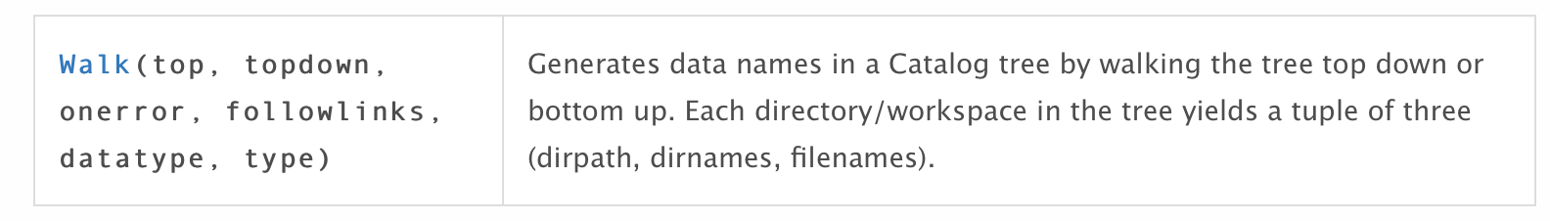

The Walk function, as Esri explain, can ‘walk’ through your folders and their respective subdirectories (or branches) and return three properties: the directory path, the directory names, and then filenames of files within the directory. These are provided in what is known as a tuple - an ordered set of immutable (unchangeable) objects. Tuples are sequences, just like lists. The differences between tuples and lists are, the tuples cannot be changed unlike lists and tuples use parentheses ( ), whereas lists use square brackets [ ]. Creating a tuple is as simple as putting commas in between each separated value.

The Walk function takes multiple parameters, although the only one you need to set is top, i.e. the top-level workspace that is of interest. There are two Walk functions presented by Esri.
The first is one that is part of the Operating System (os) Python library - this can be used to iterate or walk through folders to find additional subfolders and files. However, os.walk is strictly file based and does not recognize databases and non-file-based data types that are important in ArcGIS. For instance, os.walk will not see raster datasets or other contents in a file geodatabase workspace or a feature dataset.
The second is the Walk function within the arcpy.da library-module. Whilst the functionality of the arcpy.da.Walk function is almost the same as os.walk, the function can also be used to iterate through a directory, and can also look into databases and identify ArcGIS data types.
To use our walk function, we follow a similar script to the List functions, where we set the output of the Walk function to a variable. But to use the output of the walk function, we need to add a little more code to end up with a similar listing pattern.
As stated, the output from our walk function is a tuple containing the dirpath; dirnames and filenames. As we look at the Help documentation from Esri, we can try to understand what this tuple is going to look like:
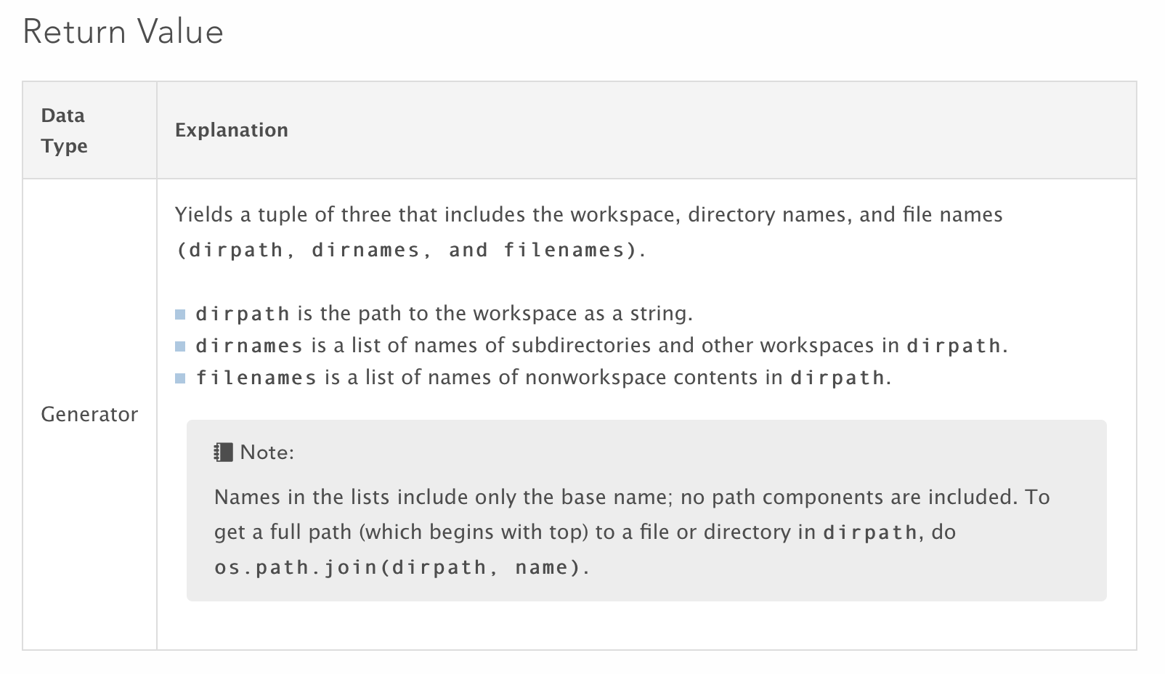
In our case, our first object in our tuple, dirpath will store the path to our workspace as a string: “H:/Bootcamp/data/raw/crime_by_month/”.
Our second object will be a list of the folders within this workspace: [“2016-04”, “2016-05”, “2016-06”, “2016-07”, “2016-08”,“2016-09”]
And our third object will be a list of the files within this workspace: [“201604.csv”, “201605.csv”, “201606.csv”, “201607.csv”, “201608.csv”, “201609.csv”]
The latter two are also stored as strings within these two lists, within our tuple! It’s something to get your head around, that a tuple can contain other python objects such as a whole list!
18. To be able to create a loop for our crime data, we need to use the Walk function to first catalogue our data. We then need to find a way to add each dataset to a separate list that will be used within our for loop from the tuple output. The full data path needs to provided for each of these datasets.

Fortunately for us, Esri once again provides us with a useful example from which we can borrow and edit code:
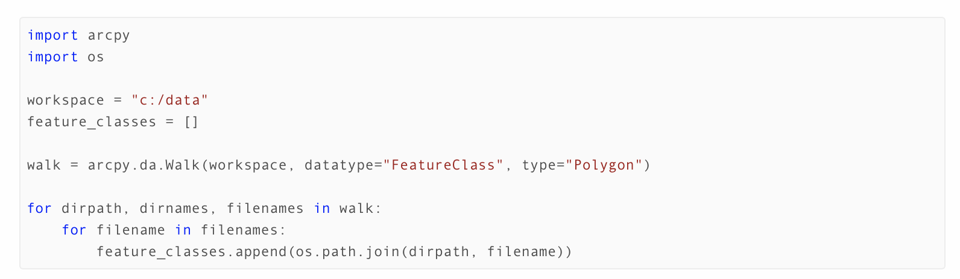

As you can see, we’re actually going to use another for loop to generate our list.

19. In your scripting editor, delete any of the code bar our import statement and setting the workspace.

20. Add the import os statement and create an empty list called crime_tables:

# This script catalogues the tables within the Crime Data folder

import arcpy
import os

# Set our workspace to our folder of interest
## Note, as we’re using the Walk function here, we do not need to set an env.workspace
## And instead can just use a variable called workspace

workspace = "H:/Bootcamp/data/raw/crime_by_month/"

# Creates an empty list variable, crime_tables

crime_tables = []

21. We now want to add in our looping code - and we’’ll take this straight from the Esri example with two edits: (1) remove the constraints in the Walk function and (2) change the variable name from feature_classes to crime_tables:

# This script catalogues the tables within the Crime Data folder

import arcpy
import os

# Set our workspace to our folder of interest

workspace = "H:/Bootcamp/data/raw/crime_by_month/"

# Creates an empty list variable, crime_tables

crime_tables = []

# Sets our walk variable to the tuple output of the Walk function on our workspace
walk = arcpy.da.Walk(workspace)

# Set each object of our tuple output to the associated variable,
# And for our directory and the directories within this directory:
# Walk through every single folder in workspace and for each folder, and
# return the current folder path as well as the directory names and filenames
# within that folder.
for dirpath, dirnames, filenames in walk:
# And then for each filename found in the tuple object, filenames
for filename in filenames:
# Join the dirpath and filename together using the os.path.join function
# And append (add) - a built in python function - this as an object to our
# crime_tables list
crime_tables.append(os.path.join(dirpath, filename))

22. We can check to see if our cataloging has worked by adding in a print statement to print our crime_tables list.
# This script catalogues the tables within the Crime Data folder
import arcpy
import os

# Set our workspace to our folder of interest
workspace = "H:/Bootcamp/data/raw/crime_by_month/"

# Creates an empty list variable, crime_tables
crime_tables = []

# Sets our walk variable to the tuple output of the Walk function on our workspace
walk = arcpy.da.Walk(workspace)

# Set each object of our tuple output to the associated variable,
# And for our directory and the directories within this directory:
# Walk through every single folder in workspace and for each folder, and
# return the current folder path as well as the directory names and filenames
# within that folder.
for dirpath, dirnames, filenames in walk:
# And then for each filename found in the tuple object, filenames
for filename in filenames:
# Join the dirpath and filename together using the os.path.join function
# And append (add) - a built in python function - this as an object to our
# crime_tables list
crime_tables.append(os.path.join(dirpath, filename))

# Print our resulting list
print(crime_tables)

23. Save your script and run your code.

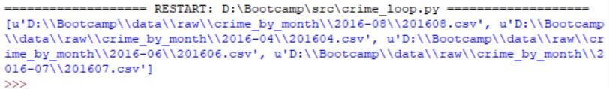

24. If your code is working, you should now see a list of the crime csvs with their respective data files.

A quick note on the .append() function: you’ll have noticed you’ve used a new function in your code this afternoon called .append(). We’re going to explain this function in more detail tomorrow, but to the basics of it is that it adds whatever string you pass through its parenthesis to the list on which you’re calling it. This is a type of Object Oriented Programming that again we’ll look at in more detail tomorrow. For now, we’re just using it to build our list!

Creating a For Loop with Variable Substitution: Step Three (Loop Script)

25. We now have a method to generate our list of csvs ready to loop. We now need to transfer this code into our stepthreetest.py script. But as we’re aware we might make mistakes - we want to keep an original version of this working script clean. To do this, return to your stepthreetest.py window and Save As a new file, called stepthreetestloop.py. Make sure to close down the original script and only edit our loop version.
26. Within this loop version, we first want to add in any new dependencies we’ve created i.e. add in our import os statement below the import arcpy statement.
27. Next, we can add in our workspace variable underneath our Global Variables list. Add the # Set the current workspace comment above our workspace variable as well.
28. We can then copy over the rest of our list generating code from our crime_loop code underneath the current workspace variable in our stepthreetestloop script - from our empty crime_tables list variable to the end of our append for loop (we don’t need to keep the print statement this time - we know the code works!).
29. We’re now ready to create our processing for loop, within which we’ll need to move all of our processes inside - and substitute where necessary our ‘crime_table’ loop variable within our datasets, paths, file names and fields (exactly like we did in ModelBuilder within Inline Substitution).
30. First, underneath your append for loop, add what will be our new for loop statement:
# This script is a playground for testing out our Crime Rate generation code
# Written by Joanna Wilkin

## Required libraries
import arcpy
import os

# Global variables
data_path = “H:/Bootcamp/data/”
working_files = “H:/Bootcamp/data/working_files/”

# Set the current workspace
workspace = "H:/Bootcamp/data/raw/crime_by_month/"

# Creates an empty list variable, crime_tables
crime_tables = []

# Sets our walk variable to the tuple output of the Walk function on our workspace
walk = arcpy.da.Walk(workspace)

# Loops through our directory and directory paths to...
for dirpath, dirnames, filenames in walk:
# And then for each filename found in the tuple object, filenames
for filename in filenames:
# Adds each crime csv to the crime tables list
crime_tables.append(os.path.join(dirpath, filename))

# For each of our csvs in our table list:
for crime_table in crime_tables:

31. We now have the start of a for loop that will iterate through each of our csvs in our crime_by_month folder (and its subfolders). We now need to “move” the remaining processing code (what we wrote for the original stepthreetest.py script) into the for loop. To do so, we just need to indent all of the code by one indentation. We could tab each line one by one, but it is much easier to select all the relevant code (from the comment # Turn crime csv into… to the end of our final print statement (“File Processing Complete”) ), and then, in the toolbar of the scripting editor, go to Format → Indent Region.
32. You should see all your code shift by one indent. This means all of this code will now run within the for loop and be run on each crime_table that is passed within the for loop. Note, only the fieldmappings for loop should have any extra indentation in its formatting within this block of code. The fieldmappings for loop itself should start at the same indentation as the rest of the code and then the line starting with an ‘if’ will be indented one step further, and then the following line fieldmappings.remove another step further to this. This formatting should carry across - but just make sure you don’t undo this indentation when checking your code.

33. What we want to do next is to make sure that our script reflects each csv. First, and probably most importantly, we need to edit our first process with our Step 3 method: turning the crime csvs into the temporary XY points layer. We need to ensure that the process ingests the crime_table loop variable as the input table - and it’s as simple as changing the first parameter from crime_month_csv to crime_table. As we’ve now removed the crime_month_csv from the parameters in the MakeXYEventLayer function, we can also remove its definition as a variable from our code as well.
...
# For each of our csvs in our table list:
for crime_table in crime_tables:

# Turn crime csv into temporary xy points layer
x_field = “Longitude”
y_field = “Latitude”
crime_points = “crime_points_201604_temp”
CRS = "GEOGCS['GCS_WGS_1984',DATUM['D_WGS_1984',SPHEROID['WGS_1984',6378137.0,298.257223563]],PRIMEM['Greenwich',0.0],UNIT['Degree',0.0174532925199433]];-400 -400 1000000000;-100000 10000;-100000 10000;8.98315284119522E-09;0.001;0.001;IsHighPrecision"

arcpy.MakeXYEventLayer_management(crime_table, x_field, y_field, crime_points, CRS, "")

print(“Points layer created”)
...

34. Once we’ve made this update, we now want to ensure that any new datasets or fields that are created have names that contain the month and year for the csv being processed.
35. To do so, we need one more line of new code. As we’ve seen, the loop variable crime_table will contain the whole of the datapath for each csv. But when we’re renaming our datasets and fields, we only want to add the month and year of the csv. Using crime_table as a substitute within our dataset and field names will therefore lead to all sorts of trouble - let alone be extremely long! But what we can do is use a technique we came across earlier with lists, and that is slice our string. What we can do when we slice our string is return only a certain range of characters from a string - and if we store these characters as a new variable, we can then use this variable for inline substitution instead of our crime_table loop variable.

36. Underneath your opening loop statement, add the following code. Make sure there is an indent (again this should be automated by the scripting editor if you press return after the : following crime_tables!). Don’t worry - we’ve figured out the slicing range for you.
...
# For each of our csvs in our table list:
for crime_table in crime_tables:
# Store the 44th-49th character of the crime_table variable as a new variable
year_month_suffix = crime_table[44:50]

37. Now we just need to make our inline substitutions using our new year_month_suffix variable. Wherever you see 201604, we need to replace this with our new variable. But we also want to be careful and make sure the rest of the path and fields remain as strings. As a result, your edits should be:
crime_points = "crime_points_" + year_month_suffix + "_temp"
...
pspo_crime = working_files + "Bootcamp.gdb/PSPO_crime_" + year_month_suffix + "_temp"
...
southampton_lsoas_crime = data_path + "processed/Southampton_LSOAs_Crime_" + year_month_suffix + "_temp.shp"
...
crime_rate_field = "CR" + year_month_suffix
…
print(year_month_suffix + " file processing complete")

38. We’ve now finished our for loop - we’ve:

- Added in the for statement and ended it in a : ,
- Indented the code within the loop,
- Changed our input variable to the loop variable,
- And updated our dataset, paths and fields with a part of the loop variable to ensure each of these reflect the csv being processed.

Let’s go ahead and save the script.

39. We can now make one final edit. Before running most of our previous scripts, we’ve needed to delete any of the datasets that we had already generated during testing to ensure we did not end up with an error from Esri stating the file already existed. To avoid having to go in and delete the data each time, we can add another environment setting that allows us to overwrite data, by setting overwriteOutput to True. Below your workspace variable, add the code as shown:

# This script is a playground for testing out our Crime Rate generation code
# Written by Joanna Wilkin

## Required libraries
import arcpy
import os

# Global variables
data_path = “H:/Bootcamp/data/”
working_files = “H:/Bootcamp/data/working_files/”

# Set the current workspace
workspace = "H:/Bootcamp/data/raw/crime_by_month/"

# Overwrite existing data
arcpy.env.overwriteOutput = True

# Creates an empty list variable, crime_tables
crime_tables = []

...

40. Save your script again and then run!

41. If your loop has successfully run, we can finally add it into our original bootcampprocessing.py script.

42. To do this, copy and paste everything from # Set the current workspace to the bottom of your stepthreetestloop.py script over to your bootcampprocessing.py script, underneath the # Creating our crime rate data.

43. At the top of the bootcampprocessing.py script, add in our additional import statement for the os library.

44. Let’s also move our overwriteOutput setting to below our global variables using cut and paste. This means that this code will be read before any of the data processing, including that before our for loop, meaning that all of our data can be overwritten - and we don’t need to go looking for any temp datasets to delete. We’ll talk more about order and control flow tomorrow - but where this setting is placed in our script could change what datasets could be overwritten and which couldn’t!

45. We now have our entire processing in one script - and we need to test that it works! First save your script - and then run!

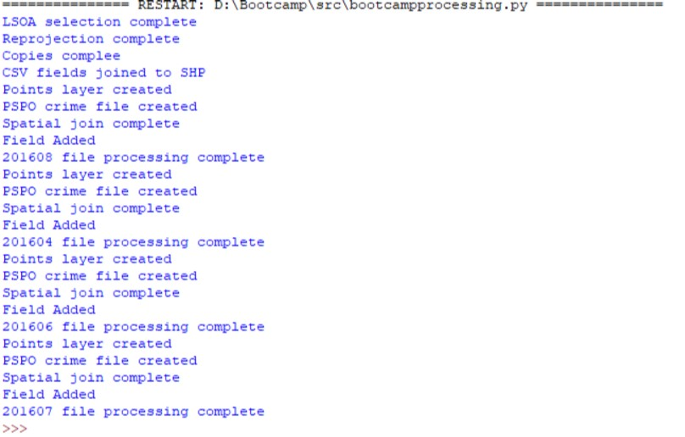

46. Fingers crossed you get all of the print statements you should be expecting. And that’s it, you’ve got your whole processing method written up as an ArcPy - Python script.

47. The final step is to remove the _temp suffix from all of your paths - there should be 7 replacements in total. You can then save and run the script again to generate our final datasets. You can then go ahead and delete any temp data from your folders and geodatabase - it is probably easiest to do this in ArcMap.

47. If you run into difficulties, you can come and grab a copy of the full working script from the front - you’ll need to study it carefully and check through to see where you’ve made any errors.

Debrief: A Cohesive Introduction to Programming within ArcGIS

Today, we’ve gone from a simple paper flowchart this morning to a fully working, replicable and repeatable ArcPy script . For example, if you wanted to repeat this analysis for the city of Bristol - it wouldn’t require too much editing to do so. Or, if we added in another 24 months of data, it would be quick and efficient to run this script again to do so.

We’ve managed to automate the ingestion and processing of our data - one of the key skills you’ll need to be a confident programmer. Getting to this stage has required developing both your knowledge of using ArcGIS software and its tool and your knowledge of some very important programming concepts, including:

- Variables and variable substitution
- Using Python functions, including walk, append
- Cataloging data and generating lists
- For loops
- Using test statements for debugging

We hope you have developed a working knowledge of how you can take simple tools and processes you’ve used before in ArcGIS - and then add them to a script. Even if you’re not fully confident about all the concepts mentioned above, you should now be able to recognise them within a script and have a basic understanding of what they are doing. We also hope you are now comfortable issuing both the Python console and ModelBuilder within ArcGIS - the latter of which has much more functionality worthy of exploring if you felt that using ModelBuilder was preferable to coding.

We’ve also spent some time using a basic IDE - and got used to the idea of developing a script, with some best practices in terms of structure, documentation and testing, as well as running this and seeing results or tests being printed to the screen and our data being generated with our folders.

Tomorrow, we’ll be revisiting many of the above concepts to really solidify our basic understand of how to use programming within GIS processing. But we’ll also be expanding our range of tools we’ll be using to do so - and of course, doing some well needed data analysis.

If you’ve got to this point and still have time left, we have three further Extension Activities for you to do. We’ll be covering the first Extension Activity in the morning to make sure everyone starts on the same footing. The other two can be used to test your new looping logic knowledge.
Extension Activity 1: Hotspot Mapping - Part A
(Multiple shapefiles)

To start our data analysis, we want to run one of the hotspot mapping tools on each month of crime rate data. We’ll be using the Hot Spot Analysis (Getis-Ord Gi*) tool to do so. But we want to automate the creation of our hot spot datasets.

What you’ll need to do is:
- Create a new script and save it within your src folder
- Set the script up following our best practices (remember the import statement)
- Decide on which List function is most appropriate to generate our catalogue of data (remember we are dealing with listing shapefiles, so whichever function you choose should be capable of listing these types of files)
- Write out our List function, not forgetting to set the appropriate workspace first
- Create a for loop to use the list function
- Run the Getis-Ord-Gi tool (http://desktop.arcgis.com/en/arcmap/10.3/tools/spatial-statistics-toolbox/hot-spot-analysis.htm) with appropriate parameters including using the loop variable to help set the Input Field.
- Make sure to save your output in an appropriate place - perhaps the hotspot_data folder within our processed folder ?

Extension Activity 2: Merging our Crime Rate shapefiles into one shapefile

For those of you who did the Extension Activity within the ModelBuilder section (answering questions on what a provided Model was likely to do), this Extension Activity will be very similar. We are going to write up that model as a script.

The model merged each month’s Crime Rate field into a single shapefile using the JoinField function - and that’s what we’ll be repeating.

What you’ll need to do is:
- Create a new script and save it within your src folder
- Set the script up following our best practices (remember the import statement)
- Within the script, first create a copy of our original Southampton_LSOAs_wgs84.shp and save it as something appropriate (e.g. processed/Southampton_LSOA_Crime_All.shp) using the Copy function (https://pro.arcgis.com/en/pro-app/tool-reference/data-management/copy.htm )
- Then decide on which List function is most appropriate to generate our catalogue of data
- Write out our List function, not forgetting to set the appropriate workspace first
- Create a for loop to use the List function
- Create a slice of the loop variable to use within our JoinField function
- Use the JoinField function(http://desktop.arcgis.com/en/arcmap/latest/tools/data-management-toolbox/join-field.htm ) with appropriate parameters including the loop variable and the slice

Extension Activity: Hotspot Mapping - Part B
(Single shapefile)

Repeat the same analysis as Part A but run this on the single shapefile we have just generated.

You’ll need to use a different List function that looks to list the fields within our dataset - but restrict this listing by only the Crime Rate fields.

Then, within our for loop, you’ll need to think carefully about which input parameter you’ll set to the loop variable within the Hot Spot Analysis (Getis-Ord Gi*) tool.

You could then re-run your code for Extension Activity 2 to merge all of our datasets into one shapefile - again, you’ll need to think about which parameters you’ll change and how.

We’ll provide the code for all three Extension Activities at the end of the course - therefore if want to try these afterwards (and get stuck), you’ll be able to see what you should use.

